Make & describe patterns with translation/rotation/reflection

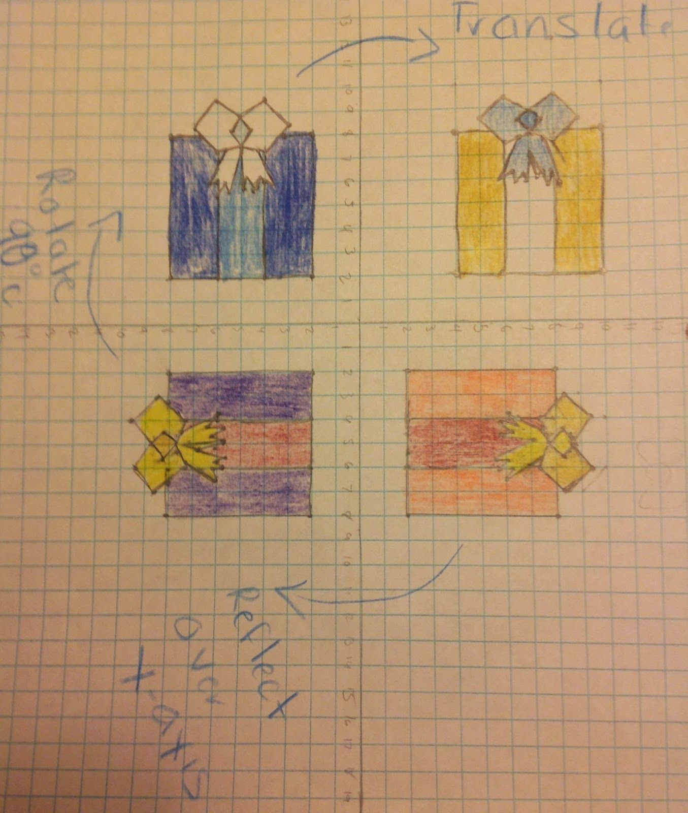
Starting with the Orange parcel.
This parcel is reflected in an imaginary mirror on the up and down axis, the vertical axis, onto the purple parcel.

To rotate, means to rotate about a point and that one point does not move. The purple box was rotated around where the axis meet at (0,0) to fit on the blue parcel.

In math Translate means to move over.

The “trans” part of the word means “across from” or “on the other side”

The top parcel every point of the blue box is moved over, and colored yellow.

Check out
https://study.com/academy/lesson/reflection-rotation-translation.html

https://www.youtube.com/watch?v=0Z1aUhGCZs0

https://www.youtube.com/watch?v=VJTxv-tRKj0

Activity 1 Follow the parcel pattern.

Fold a piece of paper in half and in half again to get four rectangles

Write the word lock down clearly in the bottom righ hand rectangle.
Reflect it (Flip it) into the left-hand rectangle,
Rotate it to the rectangle above
Translate it into the rectangle to the right

Activity 2
While I lock down see how many examples of rotation, translation and reflection you can see in day to day objects.
Take a phot or make a sketch and write an explanation of the geometric transformation (big words for rotation, reflection or reflection)

3. Translate

2. Rotate

3 Reflect
Lockdown

Spot the transformation in a house

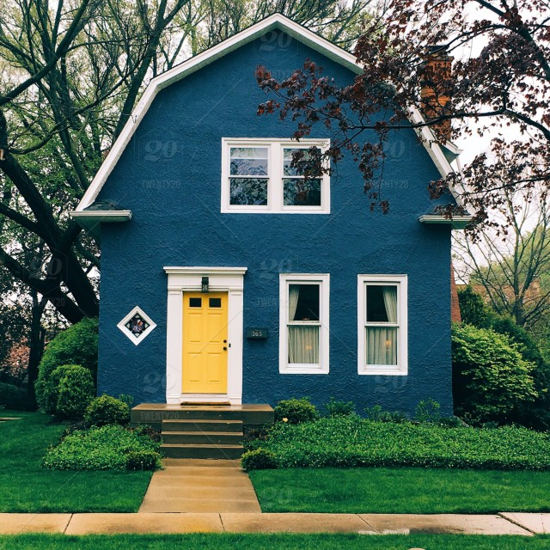
After I put the red line in you might beable to see part of the house is reflected down the middle

You can see that the bottom windows are an example of translation

If you look closely at the door you can also see examples of reflection and translation.

Interestingly sometimes a f reflection and a translation give the same result, if the image being translated or refected has a mirro line within itself.

A lot of words but look at eh blue line in the windows, showing the at half the window reflects on to itself.

When this happens I can either reflect the window or translate it to get the second window.

Activity 3
Go for a walk and take photos or sketch houses with lines of symmetry, where one half can be reflected onto the other half and look for possible transformation to describe the placement of similar shapes.
Above the windows are placed as if translated or reflected.

Activity 4
When geometric transformations are repeated to fill a page, or length of material, it is called a tessellation.
http://mathengaged.org/resources/activities/art-projects/tessellations/

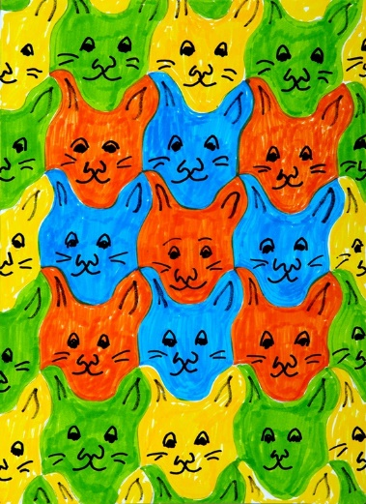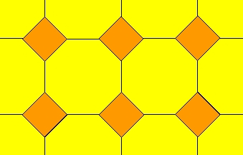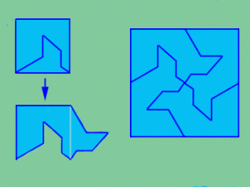

Take photos or sketch three tessellations within your house.

See if you can make a tessellation as shown in the blue and green box.

* 8 objectives not shown. See Individual Question Analysis for complete list.

