Find perimeters of common shapes.

The Perimeter is the distance around the outside of something.
If you have a ruler or tape measure you can measure some items.
If you do not have a tape measure then you can use one of your fingers which is close to 10 cm and ESTIMATE using that. Keep to the same finger

So the width of your dining table might be 90cm or 9 fingers long.

When measuring the perimeter around the outside of your house you can use “normal steps”.
The perimeter of the house is 80 meters, or maybe, 96 steps.
Activity Measure perimetres. Add items to complete the table

You are to complete this table and add some items
Item | Meters / cm | Fingers | steps
Perimeter of Dinning table |  |  | Not appropriate (na)
Perimeter of house |  | Not appropriate (na)
Perimeter of tv
Perimeter of couch
Activity 2 – Floor plan in meters or your foot size!
If you have a tape measure you could try to draw a floor plan of your house.
If you do not have a tape measure or ruler you could step it out kneel to toe!
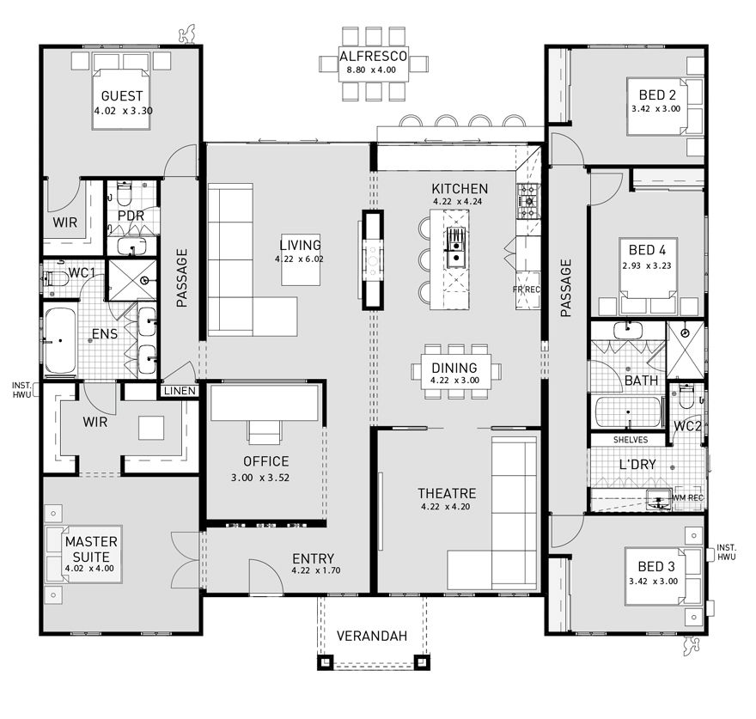
Wow! Notice how this house has a theatre room!

We call these lounges in NZ.

The numbers under each room are in meters.

