HouseHold Product as a Drawing Material

COFFEE- in a mug put 3 teaspoons of instant coffee and 3 tablespoons of boiling water (the darkness of the coffee will depend on the brand). If you feel you need to add more coffee then do so.
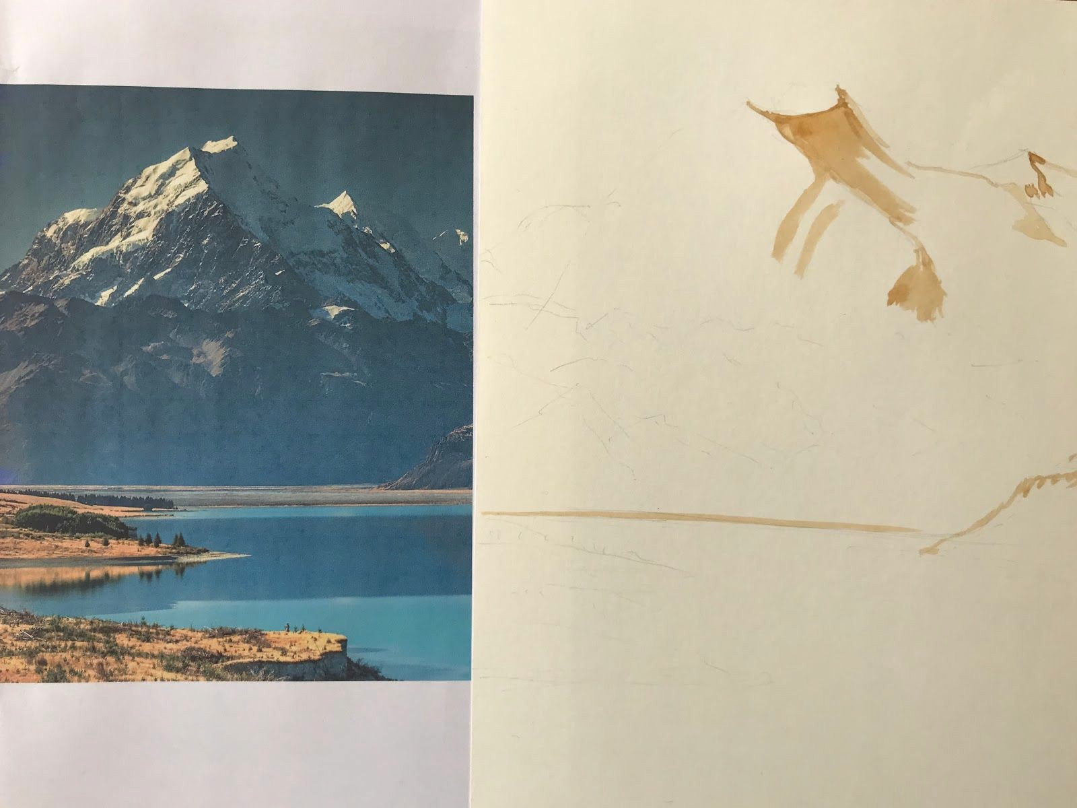
Once this has cooled down you can use the coffee as a substitute for ink. Use a plate or small bowl to mix a little of your coffee with a little extra water to dilute for the areas where lighter shades are needed.

Draw up the picture very lightly with a pencil. Don’t press hard- so you don’t need to rub out.

Your pencil lines should only be the very basics. No detail and no time spent on this stage- your time should be on the painting part.

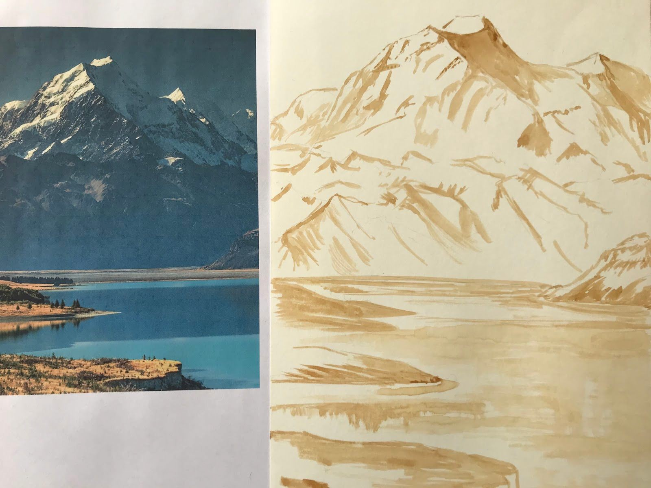
With a diluted coffee/water mix first paint in the basic lines.
Focus on the light shadow areas.

Build up the dark areas.

Switch between the diluted mix and strong coffee as you need to.

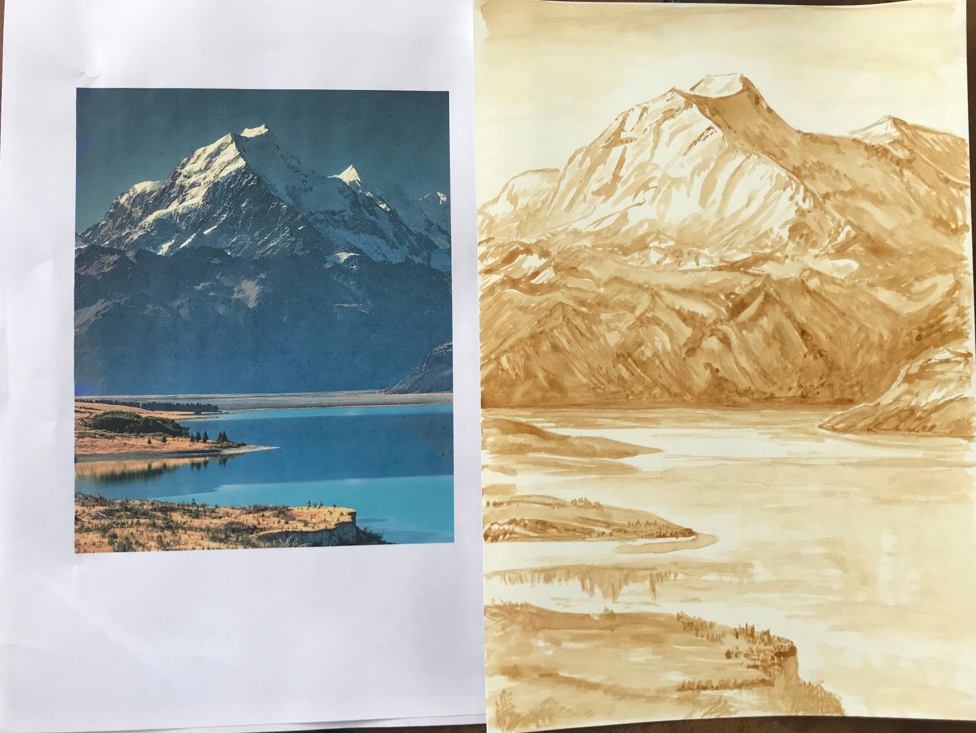
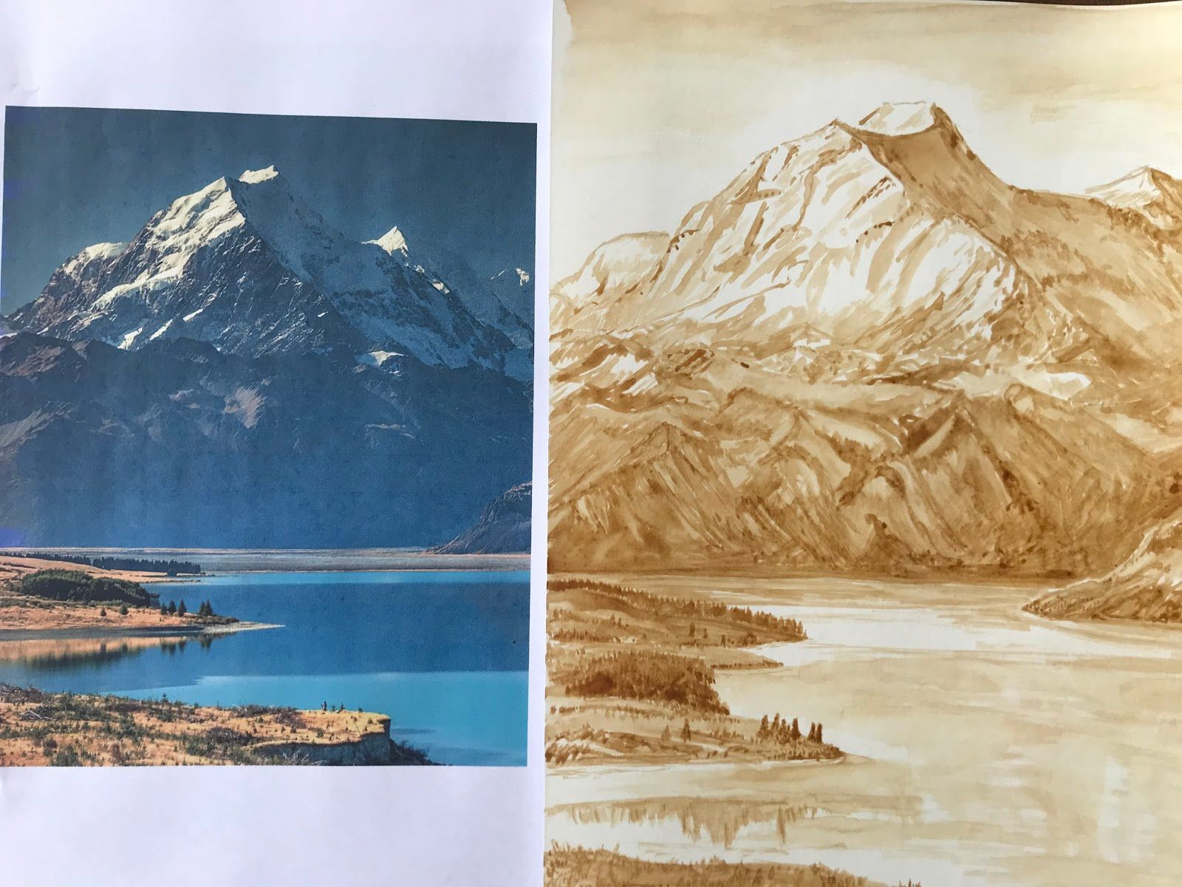
Now you just need to add the darker details in the shadows and surrounding areas.
Now build up the stronger shadows.

Start adding small details to the dark areas as you go.

Layering the coffee- wait for the first layer to dry before applying more.
Remember paper starts to peel when it gets too wet.

My finished drawing is on the next page. You can see my brush strokes and fine details. I want you to have a go at painting with coffee- you can use my picture of mt cook or find your own picture or use a photo :)
I’ll include my picture of Mount Cook that I used in the google classroom post.

