Make sensible estimates & check reasonableness of answers

Activity

During Lockdown supermarkets are not all running their specials and prices for food change.

When we go shopping, we have a rough idea how much we will spend.

When we buy our groceries the checkout person will give us a receipt.

I want you to get a receipt and fold it so you CANNOT see the cost or prices column.

I want you to copy the names of the items purchased into one column.

After you have copied it out, put the receipt away some where safe, maybe just under the paper you are writing on.

To prove you are doing the activity take a photo of the folded receipt, folded down the middle to hide the prices.

You now add another column and put the heading estimate

You are now to write what you think each item would cost.

A third column will be the item times the number purchased

Add this column up to get a grand estimate.
Item | Estimate | Price paid | Close Guess yes/no
Tomato can x2 | $3.30
White Bread | $4.00

Try doing this at least three times and record how close you get to the total.

If your household sticks to a shopping less you could try to guess how much the next total shop will be.

Show all working, show all working, show all working – don’t just guess a total figure but add the estimates of all products on the list.

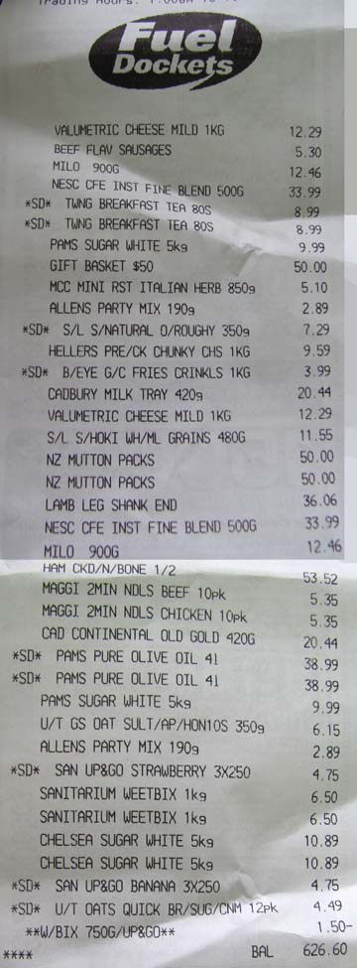
Item | Guess per Item | How Close

