COVID 19 LOCKDOWN DRAMA
Come and have a go if you think you’re dramatic enough!
This Photo by Unknown Author is licensed under CC BY-SA-NC
The following tasks can be completed in any order and range from junior to senior level drama activities. If you have a device that films and you’re up for it – make a video and send it to me! I’d love to see what you come up with! Use what and WHO you have around you and have fun with it
Choose one task per day and play it out as many times as you like or for as long as you like!

Hidden in plain sight  You must be as still as you can and ‘blend’ in with the furniture for 1 minute.  If you get caught – you are OUT!  Statues are also known as Freeze frames in Drama and used to help transition scenes.  Repeat 3 times at three different points during the day. If you can video it – even better!  This Photo by Unknown Author is licensed under CC BY-SA | Story story die  You’ll need a friend or family member to help you out with this one. You must come up with a ‘story’ on the spot and tell it as best you can. You can use props (objects around you) or you can act it out as you tell it. BUT YOU MUST KEEP IT INTERESTING!  Otherwise your audience can tell you to DIE! Which will have a consequence – of their choosing…  Improvisation (or thinking on your feet) is a vital part of drama performance  This Photo by Unknown Author is licensed under CC BY-ND | 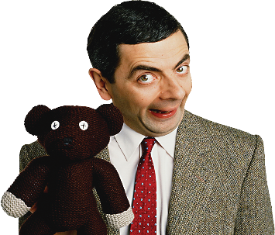  This Photo by Unknown Author is licensed under CC BY-NC  The Waiting Game  (Drama conventions: MIME)  During lockdown – a lot of what we do involves waiting. Waiting in line at the supermarket, waiting for the computer, waiting for the toilet if you have a big family and one bathroom.  Create a short skit where you have to wait in a queue for something but you MUST not speak – you can only communicate using hand gestures and facial expressions and you MUST create some sort of chaos while you wait.  Watch a professional to give you ideas…  https://www.youtube.com/watch?v=3WKmOmqC57Q
Overheard conversations  SCRIPTWORK  Some of the best scripts can start from overheard conversations. Next time you’re out on a walk or even within your own bubble, write down bits and pieces from conversations that are going on around you. Make up some characters to go with these conversations and change the place and the situation.  Can you extend on this and continue by writing your own short script? You must have a minimum of 2 characters and a maximum of 4 lines that you’ve ‘overheard’ to get you started. The whole ‘script’ should be less than 2 pages long. You can perform these when we get back to school  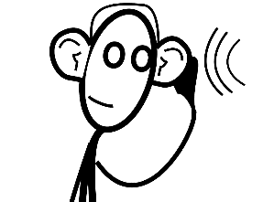 | These are the people in my neighbourhood…  CHARACTER PROFILING  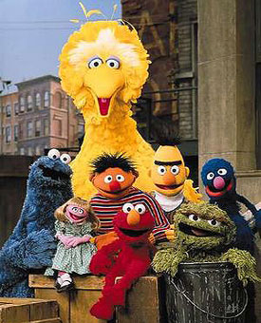  During lockdown there might be more people out and about on your street or in your neighbourhood.  See anyone interesting? Complete a character profile on them based on who you THINK they are:  Name  Occupation  Age  Greatest feature  Darkest secret  Weirdest hobby  Can you get more than one? Write your answers down and see if you can use it for your script task. | This Photo by Unknown Author is licensed under CC BY  SPACE  During lockdown – our worlds have become in some ways VERY small.  We must follow the 2 meter social distancing rule when we are out and about and whatever we do – we must remain within our BUBBLE!  Task A  Moving within your bubble. Within your home, you must try and stay at least 2 meters away from everyone else for as long as you can. How does this affect the people around you? How does this affect you?  Record your time and the reactions you get.  Task B  Still staying within your bubble – how close can you get to the other members in your home and stay that way? Longest time? Record it and their reactions! No cheating! Sleeping and watching a movie doesn’t count  In drama we must be aware of how we use our space to communicate ideas to an audience. Getting closer can mean you want to ‘be’ with someone or it can mean you want to start a fight. Think about this as you use space within your ‘bubble’.

