SENIOR DANCERS

You need to select one activity at a time to complete. There is a variety of activities and you can decide the order you complete them. They all have a relationship with Dance and the work you would be doing in class.
In your bubble see if you can get others to join in! Have some fun and if you are able to send any of your work, send it to m.saunders@jchs.school.nz or keep it and bring it to school with you to give to me

PHYSICAL – Complete both tasks.  Task 1: Spell your name and do the workout.  A – 20 Arm circles B – 20 Jumps C – 15 Squats D – 1 min Plank  E – 20 Push up’s F – 25 Star Jumps G – 15 Squats H – 15 Burpees  I – 15 Lunges J – 25 High knees K – 20 Arm circles L – 15 Burpees  M – 20 Push Up’s N – 1 min Plank O – 15 Squats P – 20 Jumps  Q – 15 Lunges R – 15 High Knees S – 15 Squats T – 20 Arm circles  U – 1 min Plank V – 15 Burpees W – 20 Jumps W – 20 Jumps  Y – 20 Lunges Z – 20 High knees  Task 2: Set the timer for 20 Minutes, put some music on and roll the dice doing each activity.  15 Push ups 15 Jumps  15 Squats 15 Burpees  15 Lunges 1 min Plank  Task 3: Join in ‘Born to dance’ on TV Channel 2 at 3pm each day. (It is also on TVNZ on demand if easier). |  | SPACE  During lockdown – our worlds have become in some ways VERY small.  We must follow the 2-meter social distancing rule when we are out and about and whatever we do – we must remain within our BUBBLE!  Task A  Moving within your bubble. Within your home, you must try and stay at least 2 meters away from everyone else for as long as you can. How does this affect the people around you? How does this affect you?  Record your time and the reactions you get.  Task B  Still staying within your bubble – how close can you get to the other members in your home and stay that way? Longest time? Record it and their reactions! No cheating! Sleeping and watching a movie doesn’t count  In dance we must be aware of how we use our space to communicate ideas to an audience. Getting closer can mean you want to ‘be’ with someone or it can mean you want to start a fight. Think about this as you use space within your ‘bubble’.
IF YOU CAN USE INTERNET
- Watch clips of dance on you tube and try to learn a sequence.
- Create or learn a Tik Tok dance.
- Do the following warm up! (you do not need a step as you can do it without) https://www.youtube.com/watch?v=jYMK7Ia7xrY
STAGE – Complete both tasks.  Task 1: Draw out stage picture and add the stage directions. You always stand on the stage and face down towards the audience.  Centre Stage (CS), Centre Stage Right (CR), Centre Stage Left (CL), Upstage (US), Upstage Right (UR), Upstage Left (UL), Downstage (DS), Downstage Right (DR), Downstage Left (DL).  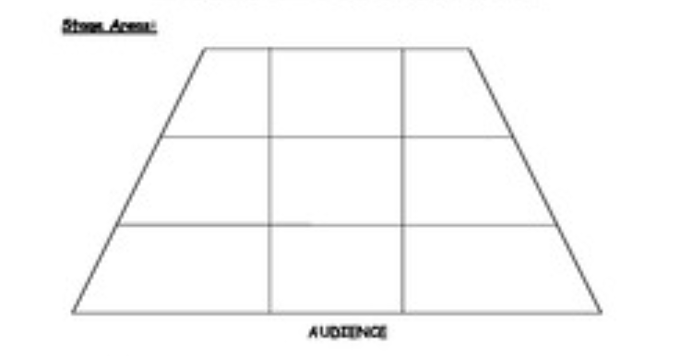  Task 2: Make a Pathway.  Walk to each square to spell out your name. You are making a pathway.  Draw your pathway name – using arrows to show the direction you are moving.  AIQY BJR CKS  DLT Start here EMU  FNV GOW HPXZ | COMPOSITION – You are going to create a solo dance based on ‘PAST, PRESENT & FUTURE’. These will be your three sections. Complete the tasks for each section. Start with the PAST and complete all tasks first before moving to the present and so on. Think about if you want a prop for your dance? What music you will use? (Please make sure it is a clean version) If using words, make sure they enhance your choreographic intention and not take away from it.  PAST PRESENT FUTURE  Think about how you have felt before and during the lockdown. What are the differences you see: in yourself, your immediate bubble, the activities you have been doing etc.  Task 1: Create 4 frozen images to show life before Lockdown. i.e. arms wrapped in a hug or a high five action Task 2: Create a travelling sequence showing you freely moving around the space. Use a range of locomotor movements (walk, run, roll, turn, leap etc) Task 3: Repeat 4 frozen images Move into the present. Task 1: Create 4 frozen images to show life during Lockdown. i.e. arms crossed in front of you Task 2: Using different body parts, create 8 movements that show you are suddenly restricted in what you can do. i.e. arms stretched out in front of you, to stop you getting too close. Task 3: Think about where you will move in the space during this section so that when you do the next task you have a pathway to use. Task 4: Ask the people in your bubble to give you key words of how they are feeling during Lockdown. Use these key words to create a sequence of movements to show these feelings. Task 5: Repeat 4 frozen images Move into the future. Task 1: Create 4 frozen images to show what you think life will look like in the future after Covid – 19. Task 2: Select 8 movements from the past and present and Fragment them (Perform them in a different order). Task 3: Repeat task 2 but add a movement in between each one in the sequence. This is to show you are moving forward but never forget the past and what you went through. Task 4: Ask the people in your bubble to give you key words of what they think it will look like in the future. Use these key words to create a sequence of movements to show these feelings. Task 5: Repeat 4 frozen images with one being your final ending position. YOU HAVE A COMPLETED SOLO.

