JUNIOR DANCERS

You need to select one activity at a time to complete. There is a range of activities and they all have a relationship with Dance and the work you would be doing in class.
In your bubble see if you can get others to join in! Have some fun and if you are able to send any of your work, send it to m.saunders@jchs.school.nz or keep it and bring it to school with you to give to me

CITIZENSHIP – Find out what Citizenship means? Ask Whanau or look up on the internet.  Create a leaflet, with two parts, that explains what it is like to be a Citizen during Covid – 19.  Part 1: during Lockdown (Level 4)  Part 2: during Level 3 | CITIZENSHIP – In the dance studio  Write down your ideas of what a good citizen would look like in a dance studio. | TIME – Speech and movement.  Write 5 sentences on activities you have done during the week. Read the sentences out. Try to add different ways of reading them, i.e. fast, slow, pausing, change of voice etc Think of movements that could be added to your words as you say them. Rehearse and Perform your movements and speech at the same time.
INNOVATION & CREATIVITY.  Get creative with cans.  - What workout ideas can you think of using a tin of food as your weight? Try them out and share with your whanau. | INNOVATION & CREATIVITY.  Write down key words of how you have been feeling before the lockdown and during the lockdown. Use these to create two sequences of dance that show the audience how you were feeling through movements you have selected. | TIME – Join in the fun.  Join in ‘Born to dance’ on TV Channel 2 at 3pm each day.  (It is also on TVNZ on demand if easier).
SPACE – Make a Pathway.  Walk to each square to spell out your name. You are making a pathway.  Draw your pathway name – using arrows to show the direction you are moving.  AIQY BJR CKS  DLT Start here EMU  FNV GOW HPXZ | SPACE – Draw out stage picture and add the stage directions. You always stand on the stage and face down towards the audience.  Centre Stage (CS), Centre Stage Right (CR), Centre Stage Left (CL), Upstage (US), Upstage Right (UR), Upstage Left (UL), Downstage (DS), Downstage Right (DR), Downstage Left (DL).  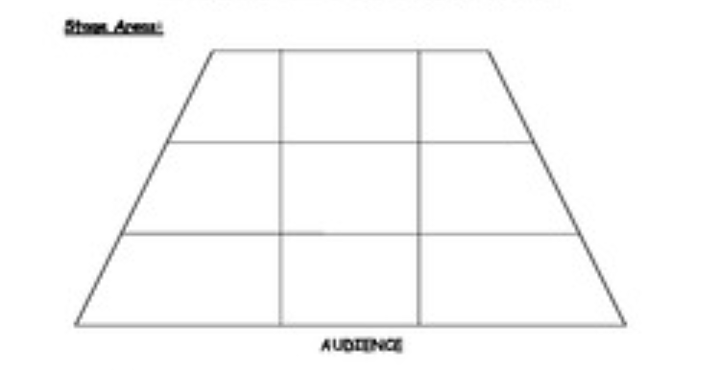
PERFORMING ARTS – Advertise a performance.  Design a poster that advertises a performance of ‘Eliminate Covid-19’  You need to include:  - Where it is being held, date and time of performance, cost of ticket, and some design using colours to make me want to come and watch this performance. | PERFORMING ARTS – GENERAL – Ticket sales.  You are selling tickets for a performance. Tickets cost: $3 per adult (A), $2 per child (C) and a family tickets (F) which are 2 adults & 3 children is $10.  Work out the costs for the following combinations.  1 A + 2 C = ? 3A + 6C =? 7A + 2C = ? 3F =? 1F + 6C =?  2F + 2A + 1C =? 4A + 4C =? 2F + 1A + 1C =? 1F + 1A + 2C =?  You now need to work out the best ticket combination for the following groups to buy.  (the top one has been done as an example) Fill in the blank boxes.  Number attending Ticket combination Number attending Ticket combination  6 Adults 6 Children 2 x family tickets & 2 adult tickets. 4 Adults 2 Children  10 Adults 24 Children 28 Adults 24 Children  15 Adults 7 Children 9 Adults 12 Children  40 Adults 23 Children 70 Adults 10 Children
ENERGY – Set the timer for 15 Minutes, put some music on and roll the dice doing each activity.  15 Push ups 15 Jumps  15 Squats 15 Burpees  15 Lunges 1 min Plank | ENERGY - Spell your name and do the workout.  A – 15 Arm circles B – 15 Jumps C – 10 Squats D – 45-sec Plank  E – 15 Push up’s F – 20 Star Jumps G – 10 Squats H – 10 Burpees  I – 10 Lunges J – 20 High knees K – 15 Arm circles L – 10 Burpees  M – 15 Push Up’s N – 45 sec Plank O – 10 Squats P – 15 Jumps  Q – 10 Lunges R – 10 High Knees S – 10 Squats T – 15 Arm circles  U – 45-sec Plank V – 10 Burpees W – 15 Jumps W – 15 Jumps  Y – 15 Lunges Z – 15 High knees
BODY AWARENESS – making sentences using dance words.  Using the following dance terminology, make a sentence with each word.  Then create a sequence of the words used in order of the sentences you created.  Roll Turn Jump Leap  Balance Walk Body parts Kneel  Melt Bend Fast Freeze | BODY AWARENESS - Pass the movement.  Ask your whanau to sit in a circle. One person shows a movement and it travels round the circle with each person performing it. It will then move to the next person (with a different movement) and it will travel round the circle. Do this until everyone has had a turn.  Now see if you can remember all the movements in order performing them as a sequence.  You can also try this standing up!
RELATIONSHIPS – Get your groove on!  Think about the people in your bubble and the types of music they enjoy. Play the songs and see if you can get your whanau to dance with you! They may even teach you some moves! If not, play music you like and have a dance! | RELATIONSHIPS – Mirroring/Reflection  With a partner stand 2 meters apart and face each other. Image you have a mirror facing you. One person moves their arm and the other person mirrors it. Explore other parts of the body.  When only one side of the body is used it creates asymmetrical shapes but if you used both sides of your body you create symmetrical shapes.  Create a sequence showing movements of both symmetrical shapes and asymmetrical shapes.
IF YOU CAN USE INTERNET  Watch clips of dance on you tube and try to learn a sequence. | IF YOU CAN USE INTERNET  Create or learn a Tik Tok dance. | IF YOU CAN USE INTERNET  Do the following warm up! (you do not need a step as you can do it without).  https://www.youtube.com/watch?v=jYMK7Ia7xrY

