Continue sequential pattern & describe the pattern
Find a pattern in your neighborhood and describe it (include numbers)
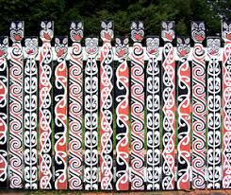
This fence is made up of groups of four.
The group of four has two heads
A long with a head followed by a short
A different long with a head and a different short.

Then the pattern continues repeating a set of four.

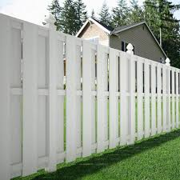
This fence is made up of “bays” or “units”.
It starts with a post with a fancy top and then there are 10(?) boards in sets of two before the next post.

So 5x2 boards between posts
10 boards between each post.

I want you to find five to ten patterns in your neighborhood while you walk about.
Sketch what you find or take a photo and paste it into word or share the photo with a description of the pattern (in words)

