Collect & display data using pictograms.

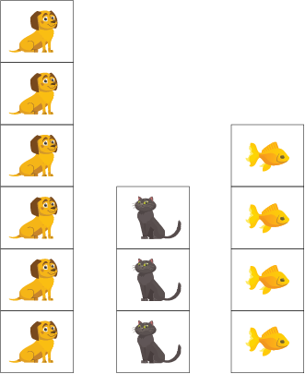

This is a Pictograph where the class has recorded how many have a dog, cat or fish as a pet.
Because there are 6 pictures of dogs we can tell that 6 students have dogs for pets.
Three students have cats for pets and four students have fish at home.

Activity 1
Using a pictograph like the one above and create a pictograph showing how many chairs, beds and tables are in your house.

Activity 2
Choose some activities or things you have,
for example, computer games, balls, puzzles
or hours reading, screen time, eating, walking.
Choose a simple picture to represent each game or activity and show in a pictograph.

