James Cook High School 2020
VISUAL ART department
Mrs Katrina Bungard

VISUAL ARTS
PHOTOGRAPHY

LEVEL TWO
AS91307 Version 2
VISUAL ARTS PHOTOGRAPHY 2.1
INTERNAL ASSESSMENT
CREDITS: 4
Demonstrate an understanding of methods and ideas from established practice appropriate to PHOTOGRAPHY.
Achievement | Achievement with Merit | Achievement with Excellence
Demonstrate an understanding of methods and ideas from established practice appropriate to photography. | Demonstrate an informed understanding of methods and ideas from established practice appropriate to photography. | Demonstrate an in-depth understanding of methods and ideas from established practice appropriate to photography.

“Approaches to invented images”

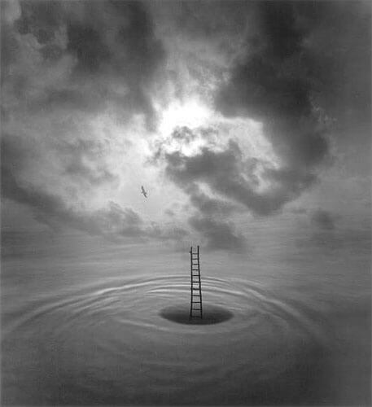

Visual Arts 2.1: Demonstrate an understanding of methods and ideas from established practice appropriate to PHOTOGRAPHY
“APPROACHES TO INVENTED IMAGES”
CONDITIONS:
This achievement standard, and the three tasks involving researching a style, Photographers and identifying conventions should take approximately 30 Hours of course work time.
DUE DATE:
22nd May 2020

Task One: (8 Hours)
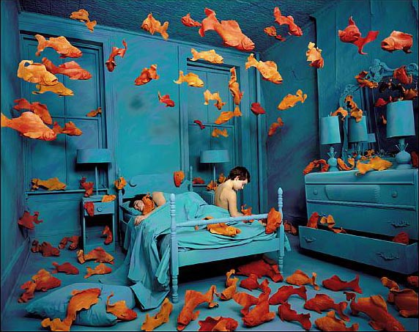
Research photomontage and staged photography.

Task Two: (12 Hours)
Choose Photographers and Analyse.

Task Three: (10 Hours)
Critically analyse relationships between Photographers and their key conventions.

(Times are an indication only)

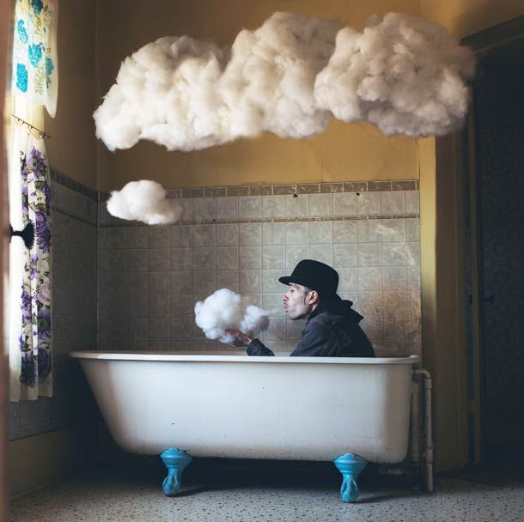
This activity involves the production of workbook-based material, which will serve students as inspiration for their photography work this year. Students will need to keep all of their notes in their workbook, as these will also contribute to their overall grade.

SUBMISSION CHECKLIST

- Task One: 2 x worksheet pages on photomontage and staged photography. (Template 1 & 1B provided)
- Task Two: 3 x A3 pages on chosen photographers. (Template 2: Artist analysis worksheet provided)
- Task Three: 1 x A3 worksheet connections page (template 3 provided)

INTRODUCTION
This assessment activity requires you to demonstrate an understanding of the key methods and ideas of photomontage and staged photography. You will investigate and explain the works of a minimum of three photographers and analyse the concepts of photomontage and staged photography.
Your analysis will be recorded on your worksheets (templates provided). You will be assessed on the depth of your understanding of the particular methods and ideas used, and how the artworks are related to the context in which they are made, viewed, and valued.

IT INVOLVES THE PRODUCTION OD A BODY OF WORK THAT INCLUDES:
- Broad notes around photomontage and staged photography. (Task 1)
- Artist analysis worksheets by a minimum of three Photographers. (Task 2)
- A summary of the key findings from your analysis that contains a page of collated findings. (Task 3)

On completion of this assessment activity you will hand in your worksheets containing all three tasks. For Achievement Standard 2.1 you will be assessed on your ability to demonstrate an in-depth understanding of methods and ideas from established practice appropriate to photography.

TASK ONE: RESEARCH PHOTOMONTAGE AND STAGED PHOTOGRAPHY. (2 x A3 pages – Template 1 & 1B provided)

A3 Page: Read broadly around the theme of Photomontage (1) and Staged Photography (1B) and write relevant paragraphs and provide examples on the templates provided to demonstrate informed analysis. You need to use a wide range of sources and remember to acknowledge all of these.

POSSIBLE ARTISTS TO RESEARCH
WITHIN PHOTOMONTAGE AND STAGED PHOTOGRAPHY
Useful resources include (but are not limited to) books, websites, magazine and newspaper articles, and exhibition visits about the following art movements and artists.

Photomontage: | Staged Photography:
Hannah Hoch (Germany)  John Heartfield (Germany)  Laszlo Moholy Nagy (Hungary)  Max Ernst (Germany)  Bob Bennet (USA)  Anne Liebowitz (USA)  Maggie Taylor (USA)  Peter Greenaway (UK)  Jerry Uelsmann (USA)  Gilbert and George (UK  Jan Saudek (Czech)  Luis Gonzalez Palma (Guatemala)  Martina Lopez (Aus)  Barbara Kruger (USA)  Annette Messager (France)  David Hockney (UK)  Mary Macpherson (NZ)  Ava Seymour (NZ)  Boyd Webb (NZ)  Megan Jenkinson (NZ)  Lisa Reihana (NZ) | Loretta Lux (Germany)  Sandy Skoglund (USA)  Sam Taylor-Wood (UK)  Anthony Giocolea (USA)  David Hilliard (USA)  Duane Michals (USA)  Cindy Sherman (USA)  Wang Qingsong (China)  Gregory Crewdson (USA)  AES+F (Russia)  Mariko Mori (Japan)  Anne Noble (NZ)  Yvonne Todd (NZ)  Fiona Pardington (NZ)  Margaret Dawson (NZ)  Rhondda Bosworth (NZ)  Ben Cauchi (NZ)  Tracey Moffat (Aus)  Christine Webster (NZ)  Marie Shannon (NZ)  Deborah Smith (NZ)  Ben Cauchi (NZ)

TASK TWO:PHOTOGRAPHERS ANALYSIS PAGES( 3 x A3 pages)

Select a minimum of three photographers to research. Include at least one example by a New Zealand-based artist and one by an international artist.

Identify a typical work from each photographer for detailed analysis. Copy and Paste an image of each of these works into your worksheet templates provided.
Your notes need to cover the methods employed (the how) and the ideas behind the work (the why). Ideas should include some reference to the wider social, political, geographical, and historical influences of the photographers.

Make your notes as full as possible, one A3 page per photography model. Define those characteristics that are unique to each photographer, and the conventions which are common amongst the artists working in the theme/style.

OTHER THINGS TO WRITE ABOUT
-The photographer’s method and ideas
-Any biographical information that has impacted on aspects of their photography
-The title, size, media, and function of each photograph example you have selected
-The technical processes they have used
-Any influences from other photographers or artists
-The themes or concepts that run through the photographer’s work
-How and why the artists have made their photographs
-How and why the artists and their work are valued by the wider artistic and photographic community
- How each artists work relates to a social, political, geographical, or historical context

*Reference specific visual examples of other photographers to support your discussion
TASK THREE: IDENTIFY CONVENTIONS
1 X A3 Page

From your analysis, collate your findings in a ‘connections page’. In the compare and contrast section of the template, Identify those characteristics or conventions that are common to two or more of the works between the artist models studied.

CONVENTIONS MAY INCLUDE (BUT ARE NOT LIMITED TO):

- Mixed media or interdisciplinary approaches
- Use of space
- Using a grid
- Use of colour
- Compositional principals
- Selection and arrangement of subject matter
- Use of iconography and symbolism
- Treatment of form – distortion and/or abstraction
- Scale and/or format
- Relationship with site, environment, or viewer
- Narrative aspects or message

Test your findings by looking at a broad range of work by other photographers who work within your chosen theme. This is to see if the characteristics you have identified are common to most photographers who work within the theme, and so can be rightly considered conventions.

STUDENTS CHECKLIST: - Use the provided A3 templates to complete your work. If you find you need extra room to type on you can expand your ideas by using an extra word doc if you choose, and handing this in with your worksheets. Please label these and mark on the first worksheets if extra pages are used.

Task 1

1 x A3 worksheet template 1: Page on Photomontage

1 x A3 worksheet template 1B: Page on Staged Photography

Task 2

Analyse a minimum of 3 different photographs from different artist models (at least 1 from each photographic artist model).

1 x A3 Artist analysis template: Photographer 1

1 x A3 Artist analysis template: Photographer 2

1 x A3: Artist analysis template: Photographer 3

Task 3

1A3: Identify conventions summary of findings worksheet.

All 6 A3 template pages handed in and named!

AS91307 (2.1) Demonstrate an understanding of methods and ideas from established practice appropriate to PHOTOGRAPHY
EVIDENCE | Evidence/Judgements for Achievement | Evidence/Judgements for Achievement with Merit | Evidence/Judgements for Achievement with Excellence
TASK ONE  Research photomontage and staged photography.  2x A3 Pages.  TASK TWO  Photographer analysis pages. AT least 3xA3 research pages.  TASK THREE  Summary and  Identify connections  1 x A3 page | The student demonstrates an understanding of methods and ideas from established photography practise, within photo-montage and staged photography.  The student’s notes identify relevant information and explains the methods and ideas of three photographers.  The student demonstrates understanding of why the photo work was made and is effective.  The student identifies and describes the features of the photographers’ works and distinguishes any similarities and differences between them. | The student demonstrates an informed understanding of methods and ideas from established photography practise, within photo-montage and staged photography.  The student uses a range of sources for their research.  They identify key information about their three photographers, offering informed explanations of their methods and ideas.  The student demonstrates understanding of how and why the photo work was made and is effective, and references specific visual examples of other photographers to support their discussion. | The student demonstrates an in-depth understanding of methods and ideas from established photography practice.  The student uses a wide range of sources for their research.  They identify key information about their selected three photographers, showing in-depth analysis of their methods and ideas.  The student offers personal insight into how and why the design work was made and effective.  They examine the relationships between the approaches of the designers and significant wider social, political, geographic, or historical contexts they relate to, and references specific visual examples of other designers to support their discussion.

Explanatory notes

Understanding means to pick out and make a list of specific features that are similar or different between the approaches investigated.

Informed understanding means that you must explain why these features are similar or different. Possible reasons for this include environmental, political, social, personal, or technological changes.

In-depth understanding places the work in a much wider context. You could broaden and deepen the discussion by examining other works by the photographers or introducing other new photographers and photography works that have influenced to the development between selected approaches.

A personal summary of the influences, significance and intentions of the selected approaches helps to show a greater depth of understanding.

Please Note
-For this assignment I’m looking out for quality of discussion in your writing rather than pretty pages. Naturally you may have photos, practice sketches and different handwriting notes etc. which you can include.

