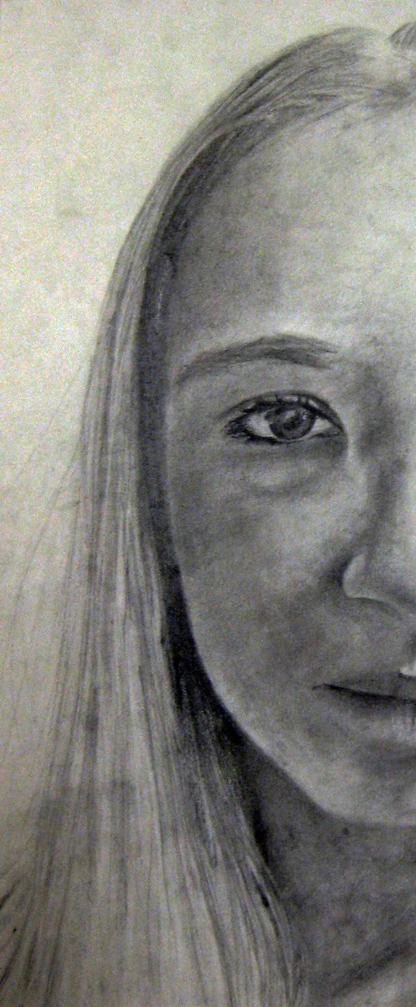

Zero to Portrait:

A guide to creating shaded portraits for beginners

Practice Sessions
Each “practice” slide should be a 20-30 minute sketch process. Make sure you erase smudges and use your paper wisely. When you are done:
Date the bottom of your drawing. Write or sign your name.

Turn in your drawing. Your photo should be taken in a bright room, but not directly under a light to avoid shadows. Make sure you take your photo straight-on, and not at an awkward angle. I should be able to see the date and your name

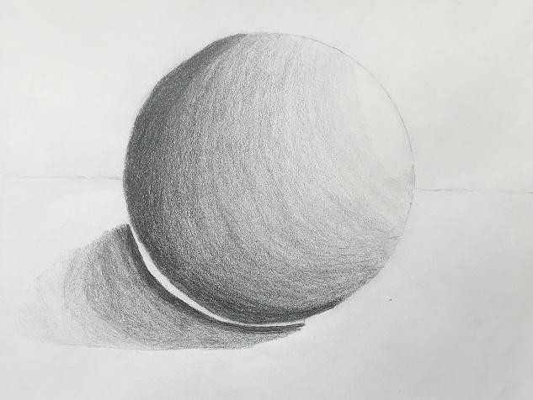
Practice Session 1:

Warm up and get your shading muscles in gear.

Before we start doing some portrait sketches, let’s work on basic shading (as a reminder for those who haven't done it in a while). This is going to be SUPER basic for some of you, but might be good practice for others. I have given you 3 options so that you can do something that you feel helps and challenges you..

Option 1- Shading 101
If you haven't shaded in a long time, or feel you know nothing about it, follow the Shading 101 video (the sphere).

Option 2- How to Shade
You are sick of spheres and want a bit more of a challenge, but still want to do something a bit basic to warm up your muscle memory. Follow the "How to Shade" video, starting at 7:25. I recommend you find an actual apple in your house or a photo of an apple for your own sketch, but she provides good guidelines. You could also try a different spherical object (like a baseball or an orange) if you want!

Option 3-
You feel comfortable with your shading abilities. This will just be practice for you. Set up an object in your house (preferably something with cool shapes, not your phone, which is flat and boring) and do a still-life sketch of it. Include cast shadows and highlights where applicable.

Printable Instructions

Student Examples
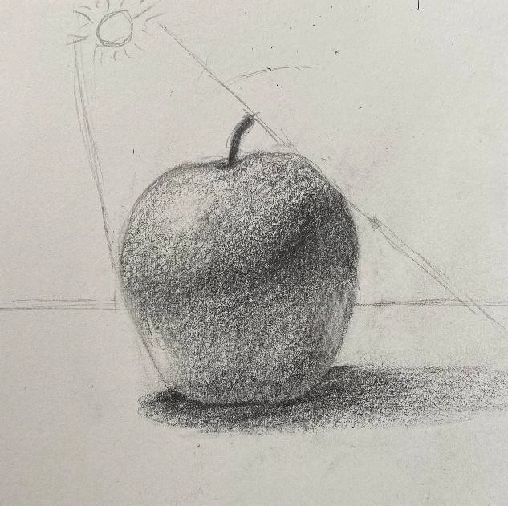

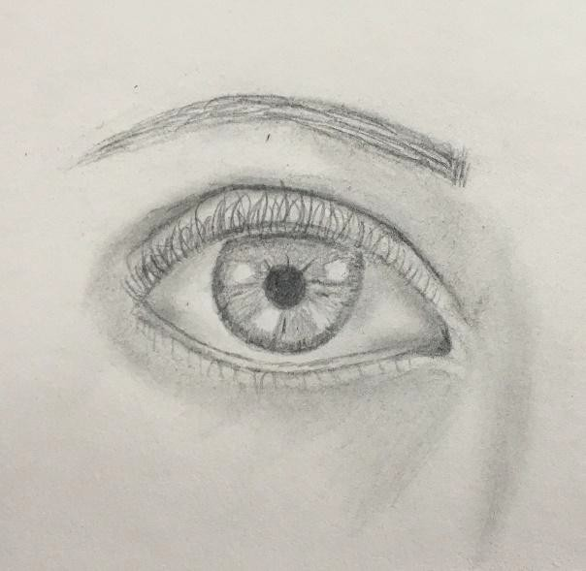
Practice Session 2:

Practice Eyes

We will go straight to eyes, because everyone loves them more than poor noses and mouths. Most videos (and myself) recommend that you find a reference photo to look at. Every picture will have different highlights and shadows, so it isn't a bad idea to look at a real eye. This would also be nice if you would like to draw a "male" eye, as most tutorial videos are ladies. I have once again given you 3 options so that you can do something that you feel helps and challenges you.

Option 1- How to Draw Eyes
Basic eye. You can just follow along with the 9 minute "How to draw eyes" video.

Option 2- Draw a Realistic Eye
This option involves a bit more shading and a little less structure talk. Follow the "Draw a Realistic Eye" video.

Option 3- How to Draw an Eye From Any Angle & Construction, Shape, & Form
You feel comfortable with your shading abilities on an eye. For this option you should try drawing more than 1 eye, attempting to draw and shade an eye facing a direction other than forward. There are ideas and tips in the two videos titled "How to draw an eye from any angle" and "How to draw eyes- construction, shape, & form".

Printable Instructions

Student Examples
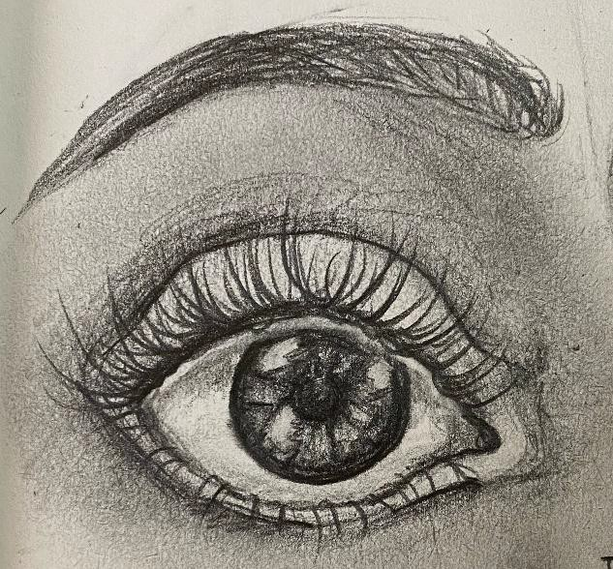

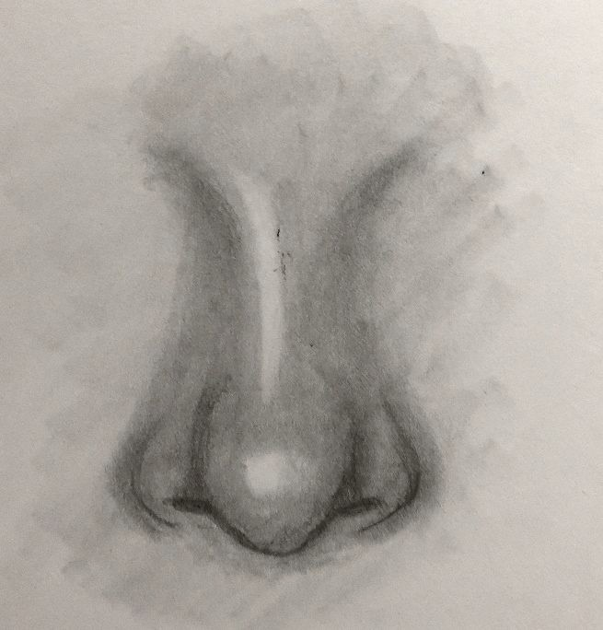
Practice Session 3:

Practice a Nose

Noses are everyone's least favorite. Let's do those next. Most videos (and myself) recommend that you find a reference photo to look at.

Option 1- How to Draw a Nose & How to Draw a Nose- EASY
Draw a nose. Either video is a good tutorial, though the one labeled EASY explains a few more differences between different nose types.

Option 2- You still have to draw a nose. But if you want to up the ante, I suggest finding a few images of celebrity or family noses and trying a few different shapes/sizes. You could also sit in front of a mirror and draw your own nose.

Printable Instructions

Student Examples
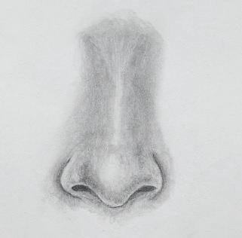

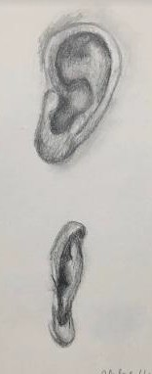
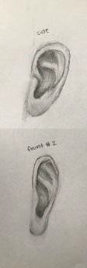
Practice Session 4:

Practice Ears

Ears are weird. I will only make you focus on them once. The goal with ears in portraiture is to make them just good enough that they can be ignored (much like real ears). Most videos (and myself) recommend that you find a reference photo to look at.

Option 1- How to Draw Ears the Easy Way & How to Draw Ears
The only option. Today is the day you all become ear experts. Watch the videos, draw at LEAST 2 ears, 1 from the side and one from the front. The second video shows her attaching the ears to the face shape for reference as well. If you are feeling squirrely- do a 3/4 view.

Printable Instructions

Student Examples

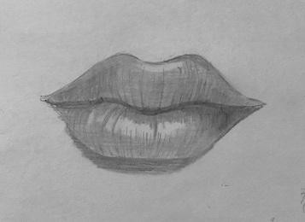
Practice Session 5:

Practice the Mouth

Last but not least, we practice drawing the mouth. Most videos (and myself) recommend that you find a reference photo to look at.

Option 1- How to Draw a Mouth & How to Draw Lips
Follow either of the "How to Draw a Mouth" or "How to Draw Lips" videos.

Option 2- How to Draw a Smiling Mouth
If you want a challenge, follow the video for a "Smiling Mouth" to practice the shape and shading on teeth.

Printable Instructions

Student Examples
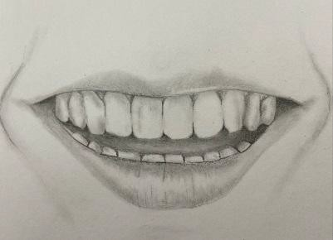

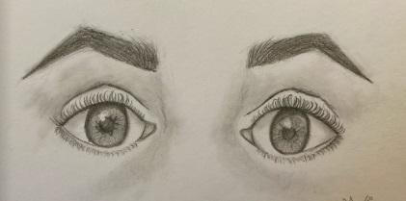
Practice Session 6:

Practice Eyes. Again

This time you need to do both eyes and focus on making them "match".

"How to Draw BOTH Eyes" is the best video to watch. It tells you how to make them match the first time.

"How to Fix Asymmetrical Eyes" is an okay video if you make eyes that do NOT match and want to fix them.

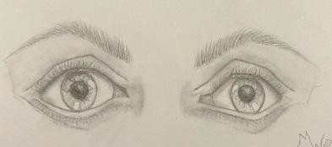
"Easy OTHER EYE" is an almost useless video, but I include it for matching eyes at odd angles. She uses guidelines (much like perspective lines) to make sure the tops, centers, and bottoms line up properly even on a 3/4 view. It is worth clicking through to see how she uses the guidelines.

Student Examples

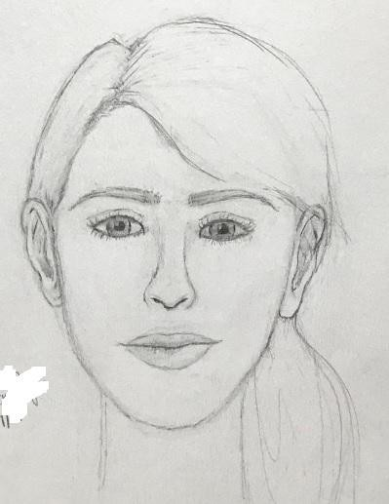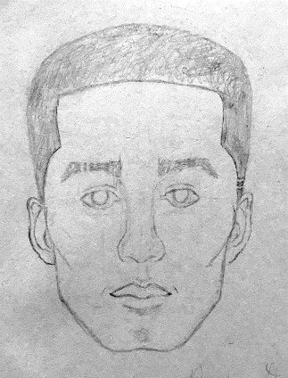
Student Examples

Practice Session 7:

Basic Proportions

Now we are going to put it all together. I do NOT want you to stress out.

You do not have to shade these, just get the proportions and features put together. You can even leave your guidelines for this exercise.

Video 1- This How to Draw Facial Proportions by Hopper is nice and slow and she explain a lot. She is weird about ears though (places them too high), so maybe ignore her on that.

Video 2- How to Draw Faces from RapidFire is faster, but also shows both a man and a woman. I like this video better, but I get that she moves very quickly.

Printable Instructions

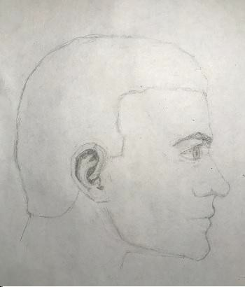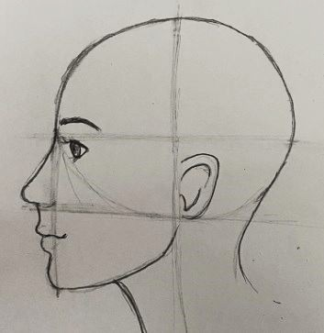
Student Examples

Practice Session 8:

Profile Proportions

Now we are going to put it all together FROM THE SIDE. I do NOT want you to stress out.
You do not have to shade these, just get the proportions and features put together. You can even leave your guidelines for this exercise.

Video 1- Facial Proportions: Profile from Hopper. GREAT video, but she also makes a very masculine face. Of course, many of you ladies may choose a male to draw for your project, so this is still something to consider.

Video 2- How to Draw a Face: Profile -Quicker, less explanation, but still good and shows a female profile

Printable Instructions

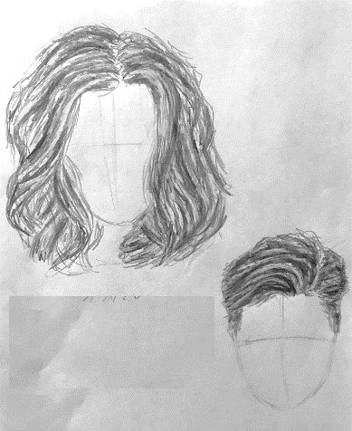
Practice Session 9:

Hair

There was really no point in practicing this until you had a head to put it on. For your official project, you will be making a finished portrait of a real person. Maybe begin to think about who you will be drawing as you practice hair today.
I want everyone to try at LEAST 2 types of hair (1 short/male, 1 long/female). Feel free to try many though, to get a feel for them. I recommend you just draw a lot of little upside-down egg shapes on your paper to represent heads and then have at it!
The key thing to remember is that hair starts on our forehead, and does not stay plastered to our skin. It should raise ABOVE the top of the head.

Video 1- Male Hair/Short Hair Video 2- Curly Long Hair Video 3- Straight Long Hair
Video 4- How to draw realistic hair- This is a good, basic look at how to shade or create realistic hair texture.

Printable Instructions

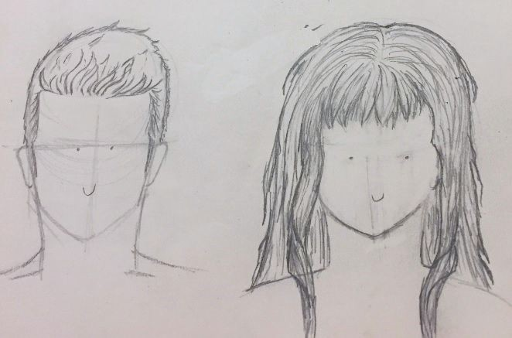
Student Examples

Practice Session 10, Final Practice:

A Complete Portrait

This can be quick and does not have to look like anyone. It can just be a generic person. You should be faster this time, and have a better grasp of how everything fits together.

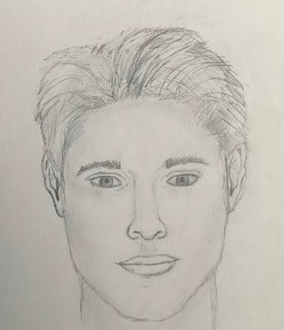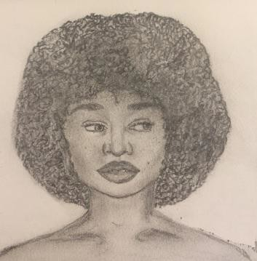
Look back on old videos if you need reminders or guidance.

Complete a generic portrait drawing with hair and some shading

Student Examples

Draw A Portrait
Find a photograph of a celebrity, a family member or friend, or even a (sigh) selfie. If you are worried about the process, try to find an image that shows the face straight on from the front. On good paper (whatever size you want!), you are going to recreate the photo.

Simple steps have been provided to help you break it down.

Turn in your drawing after each step. Your photo should be taken in a bright room, but not directly under a light to avoid shadows. Make sure you take your photo straight-on, and not at an awkward angle. I should be able to see the date and your name

Final Project: Step 1

The basic shapes
After you find your portrait photo, we can begin to sketch it out. All you need to do for the first step is to get some basic shapes and proportions sketched out (remember the proportions practice?).
First draw a circle to represent the skull, and then decide where the center line of the face is. Use these marks to give yourself references for the location of eyes, nose, mouth, ear, and jaw. If you are feeling feisty, throw some hair up there.
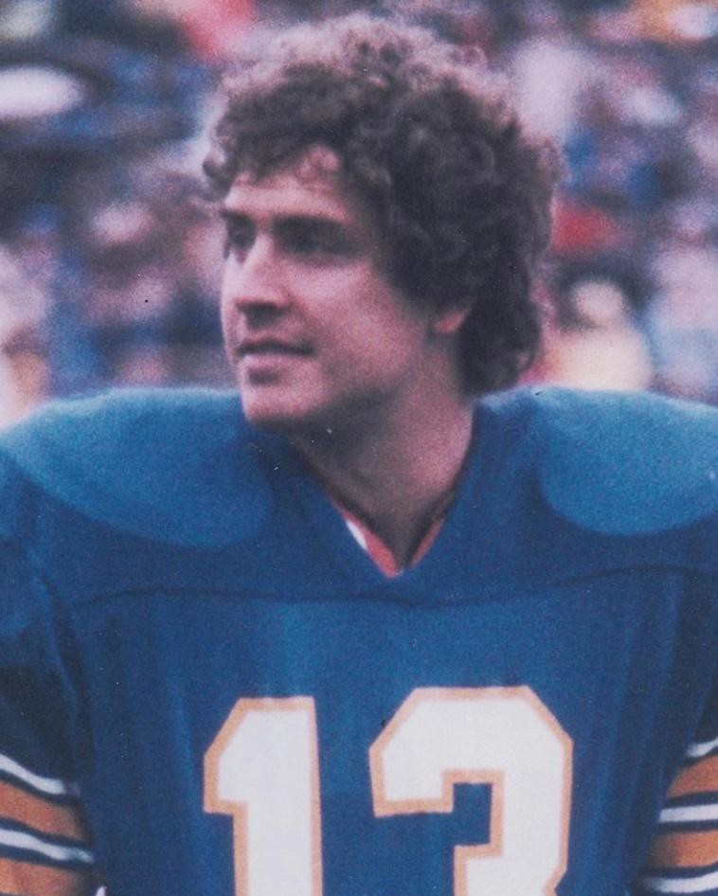
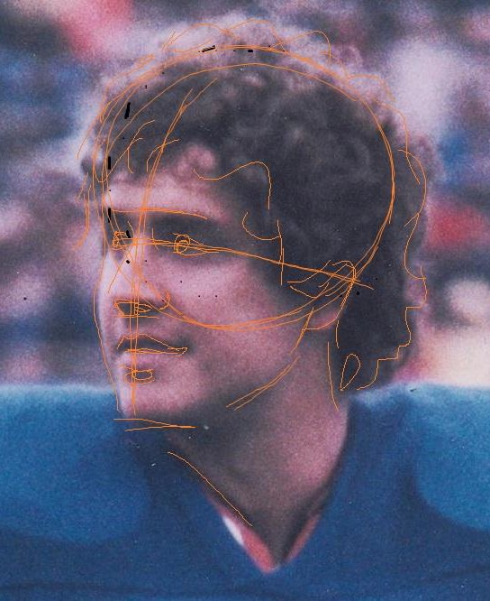
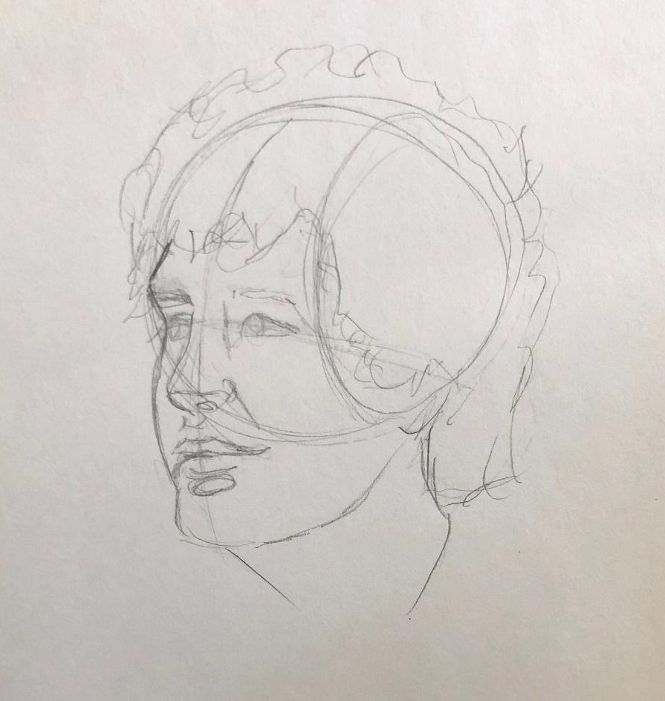
Here is a video that shows you some basic how-tos when working from a photo: Quickly Draw Heads

Final Project: Step 2

More defined detail
Next, we want to clarify the important features of the face with a little more structure. Find clearere edges and lines for the eyes, face shape, nose, and mouth.
Here is a video that shows you some basic how-tos when working from a photo: Quickly Draw Heads
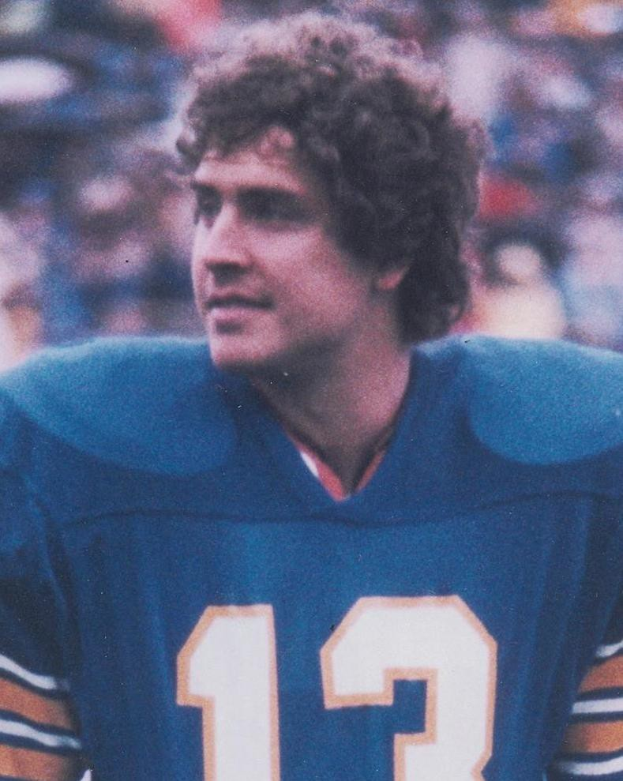
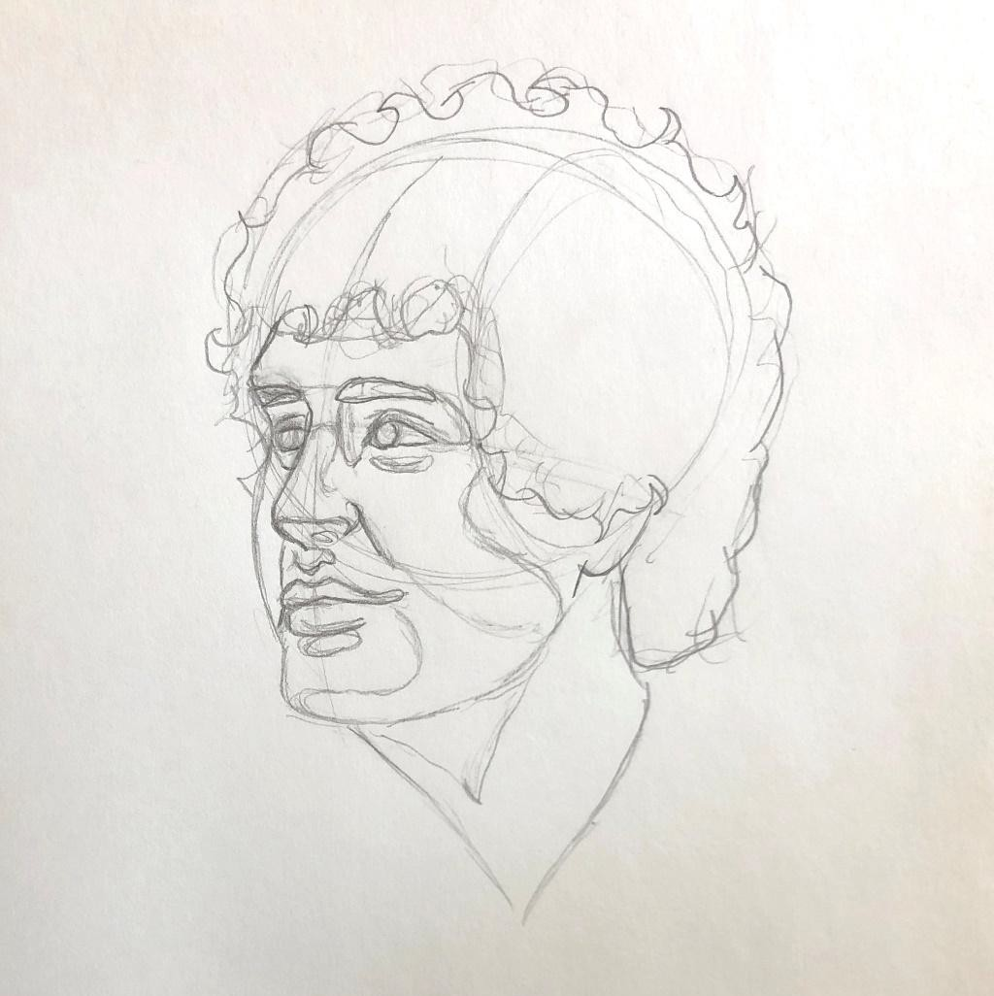

Final Project: Step 3

The other stuff
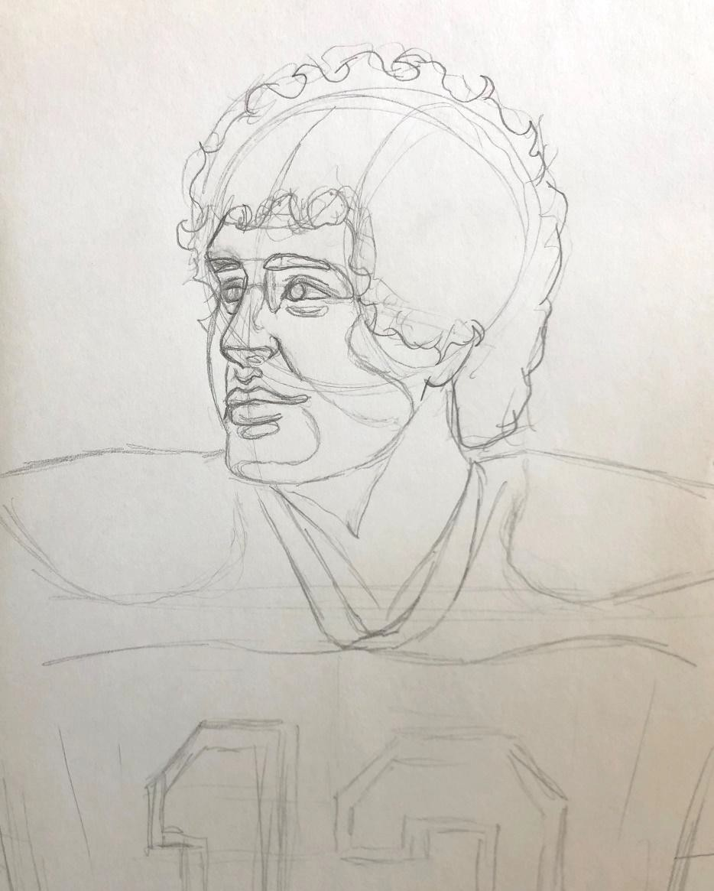
Find any other features, like ears and hair, that need to be better-defined. Add basic clothing/body/background lines. I also like to create some “map” lines for big shadow areas.

Final Project: Step 4

Clean it up
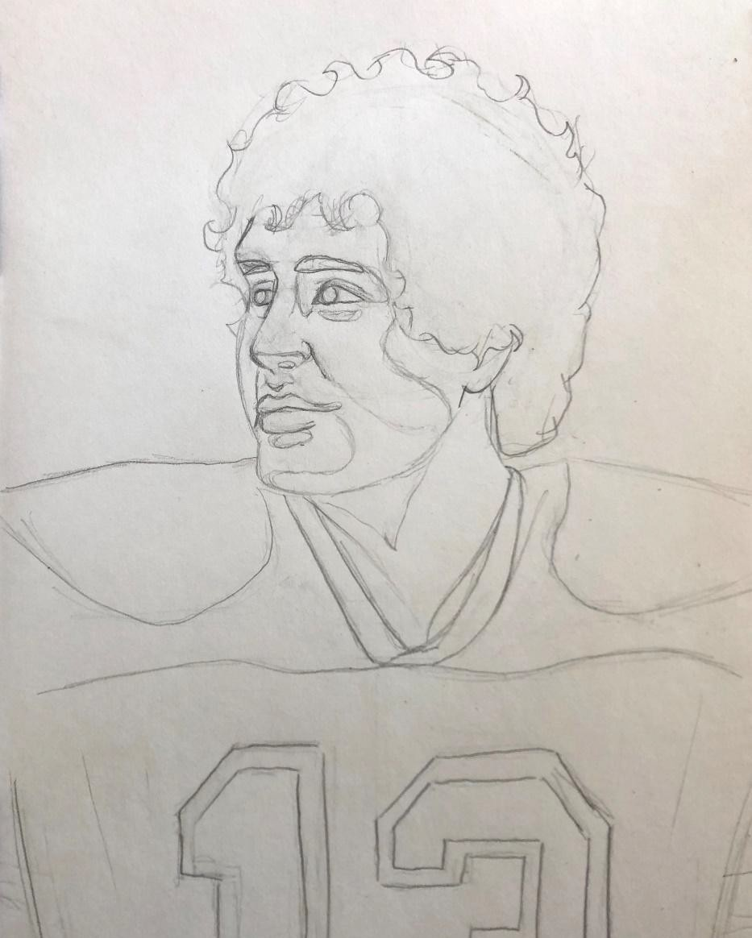
Erase any smudges and guidelines. Sharpen up and re-draw any features that may accidentally get erased.

Final Project: Step 5

Shading the Eyes
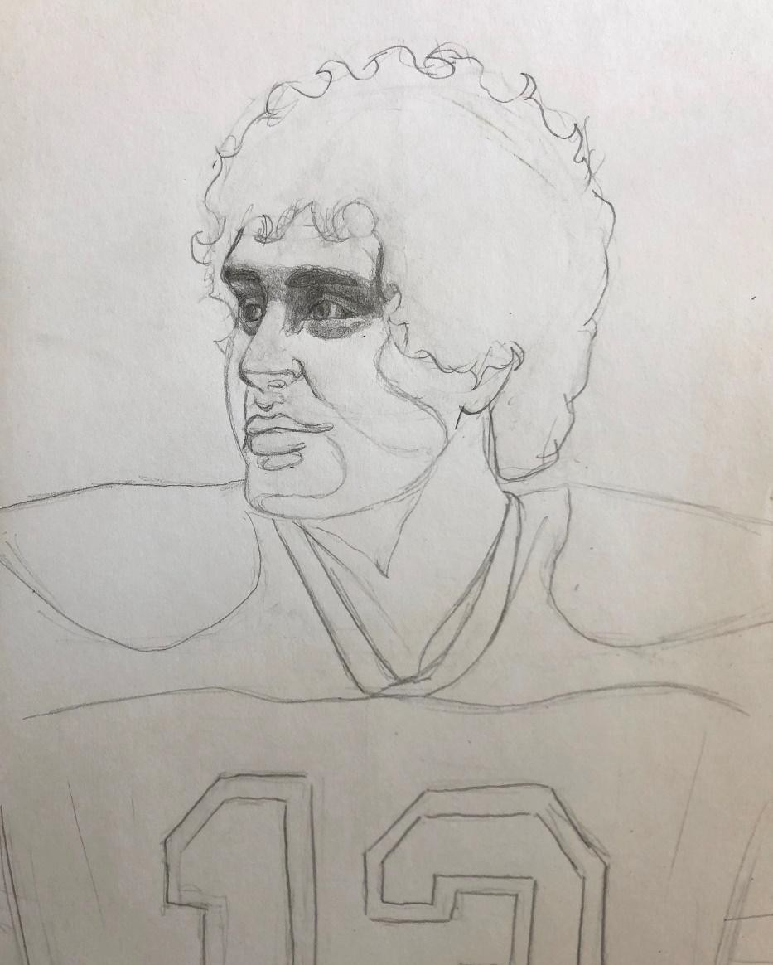
I normally wait until the end to do eyes, because it is the most satisfying part. You all know you want to just jump right in though, because it is your favorite part!

Final Project: Step 6

Shading the Nose and Mouth
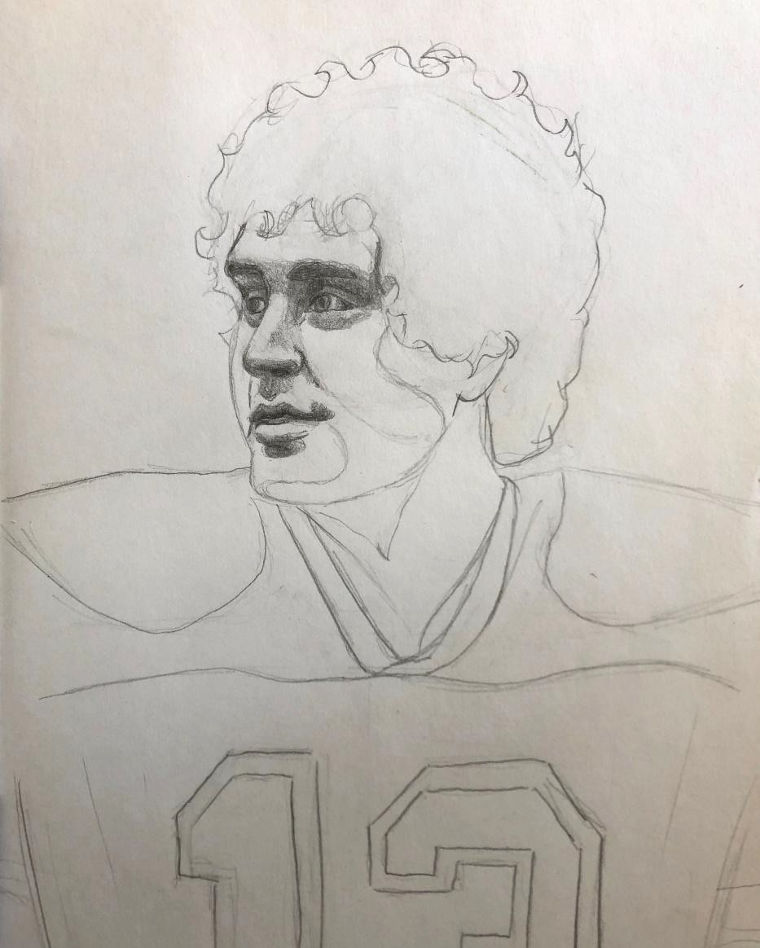
Work your way down and shade the nose and the mouth area. If you can’t see it in the picture, don’t draw it in your image!

Final Project: Step 7

Shading the rest of the face
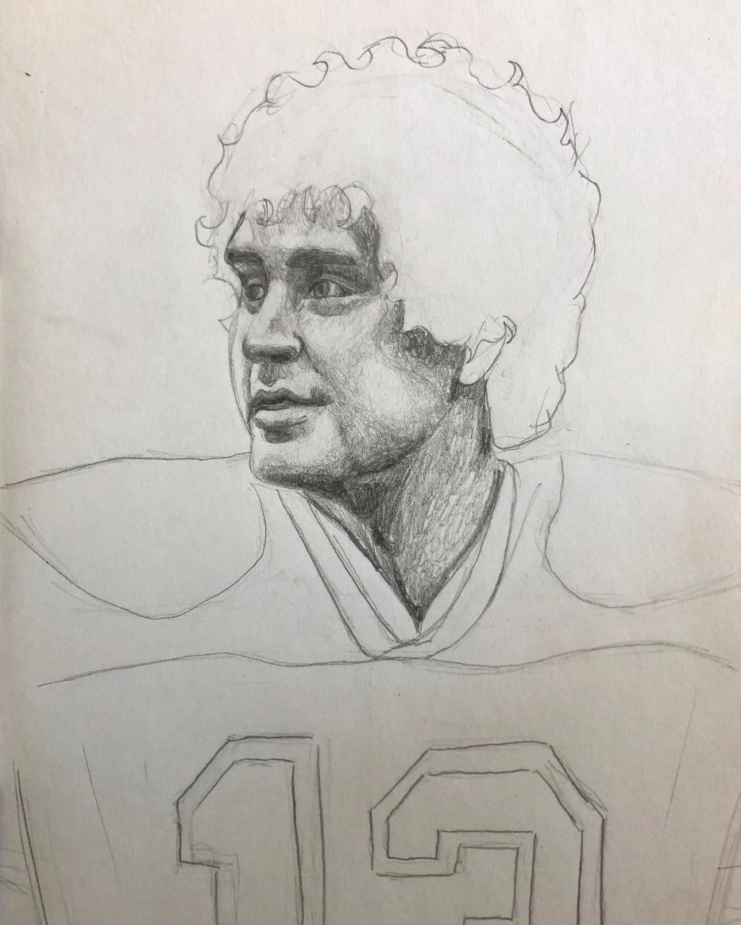
Try to fill out shadows on the cheeks, jawline, neck, and forehead. Fill out the rest of the skin (most of this will NOT be white).

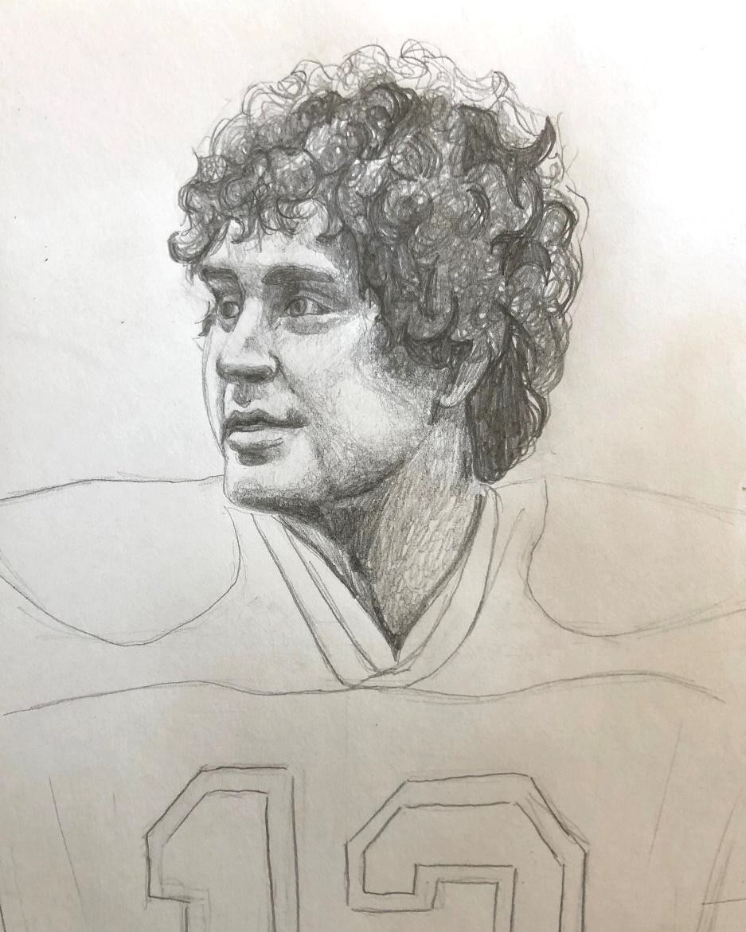
Final Project: Step 8

Hair
I always do hair in two steps. First I fill in the dark darks, areas where there is shadow shape. Then I fill in the rest with texture lines and values that replicate the type of hair. Mr. Marino has curly hair, so I used a lot of circular shading.
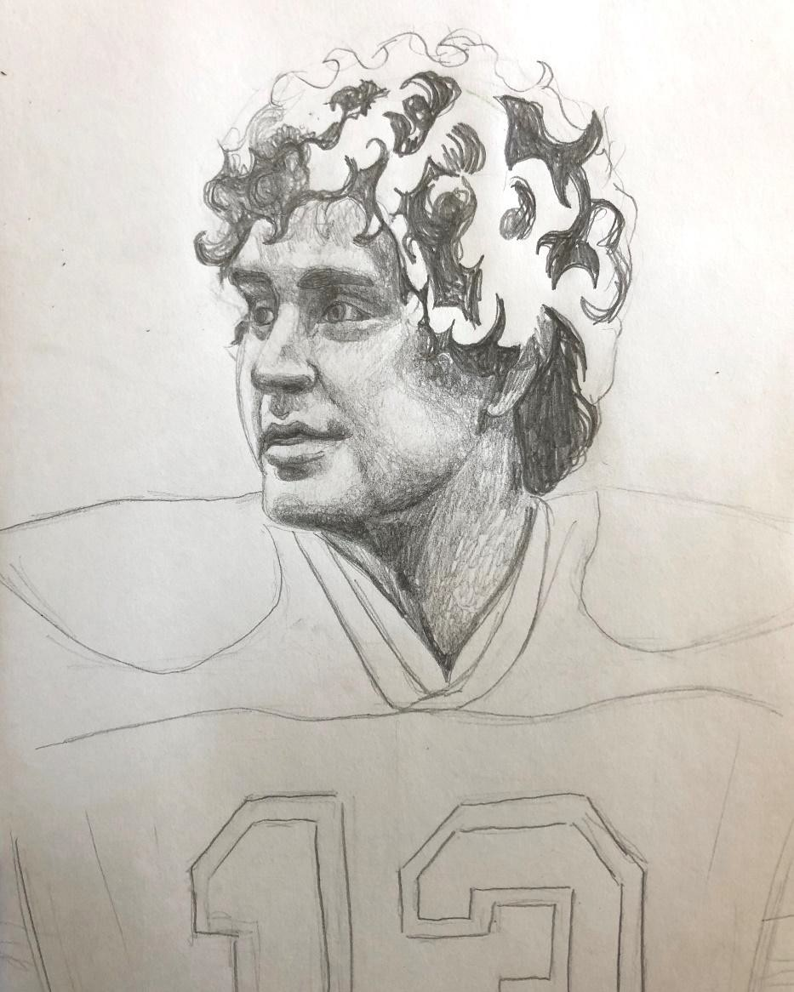

Final Project: Step 9

Almost there! Clothes/Body
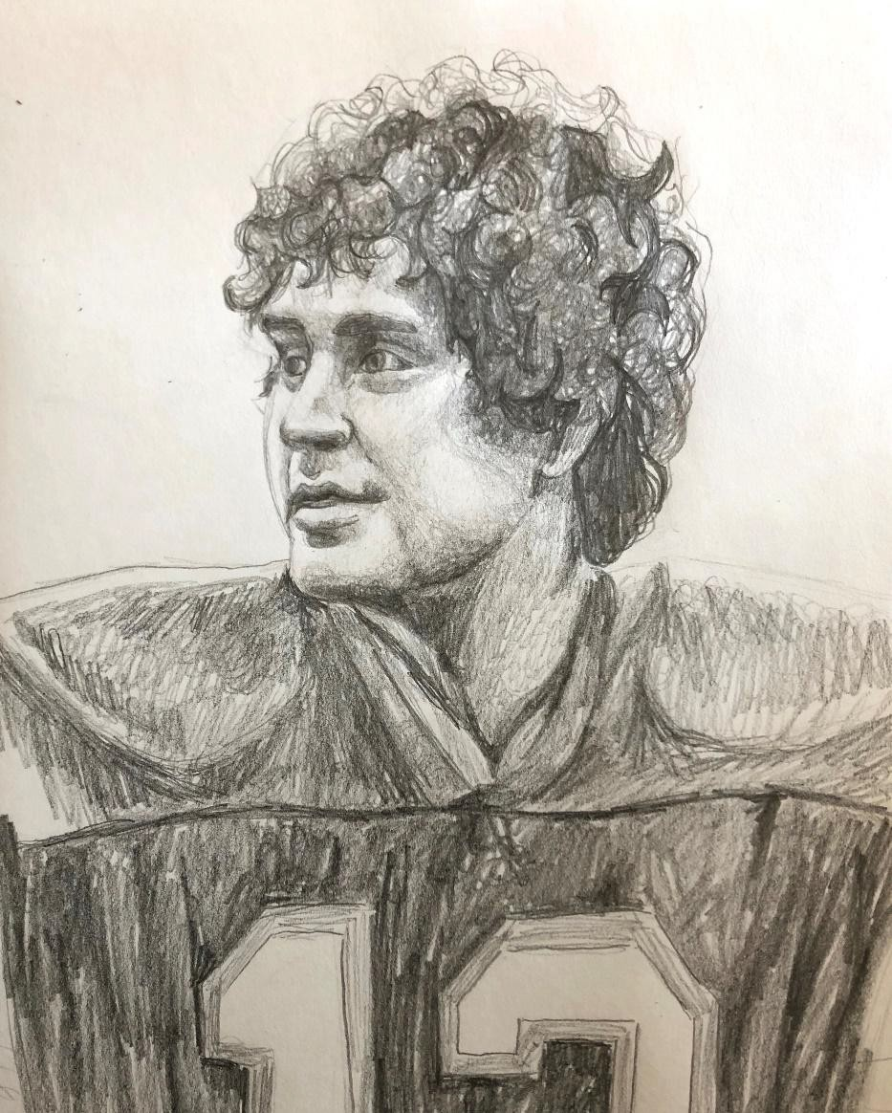
Shade the body/clothing areas. I am a firm believer that the clothes and body support the portrait. Much like the ears, this is secondary to the main features.

Final Project: This is IT

Background
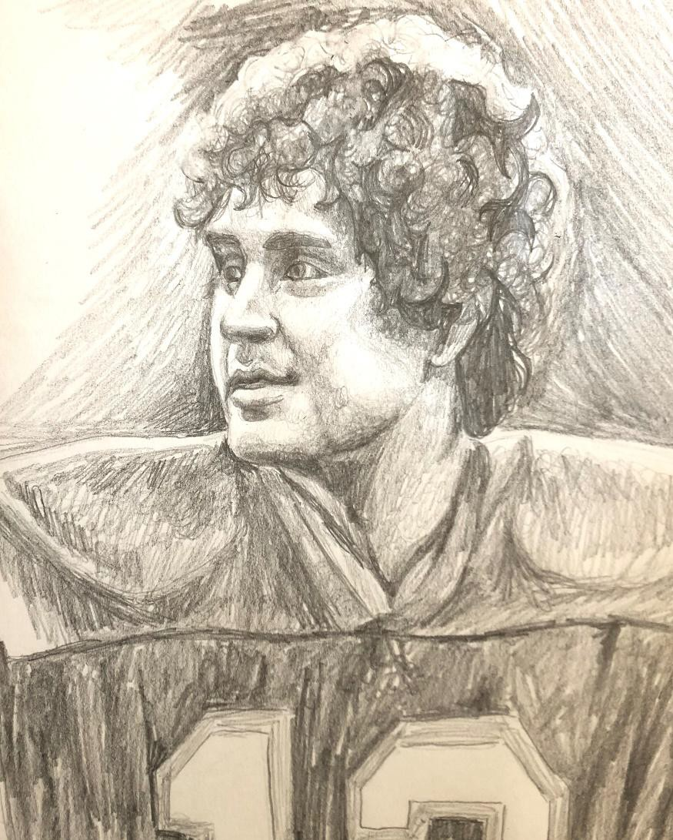
Many portraits may not need a background, but adding one makes your work look more finished. It does not have to be what is in the photo, but should compliment the image. Dan Marino has highlights on his face, hair, and shoulders in this photo that make it important to shade the background.

CONGRATS
You can now draw portraits!
Make sure you take the time to clean up smudges and trim your paper if need-be. Take a nice photo and turn it in!

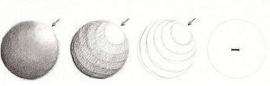
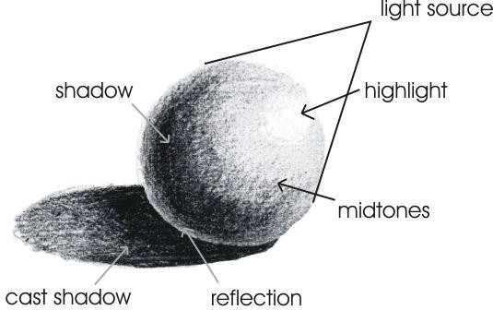

Return to Instructions

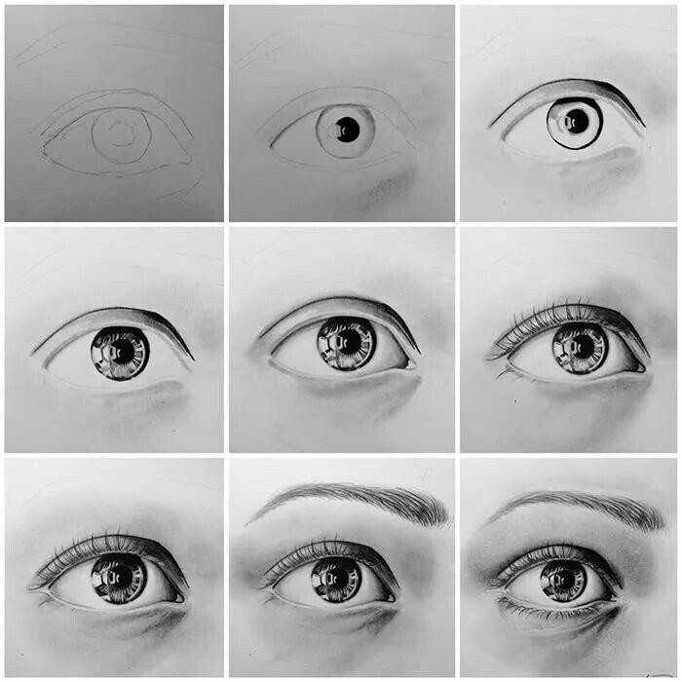

Return to Instructions

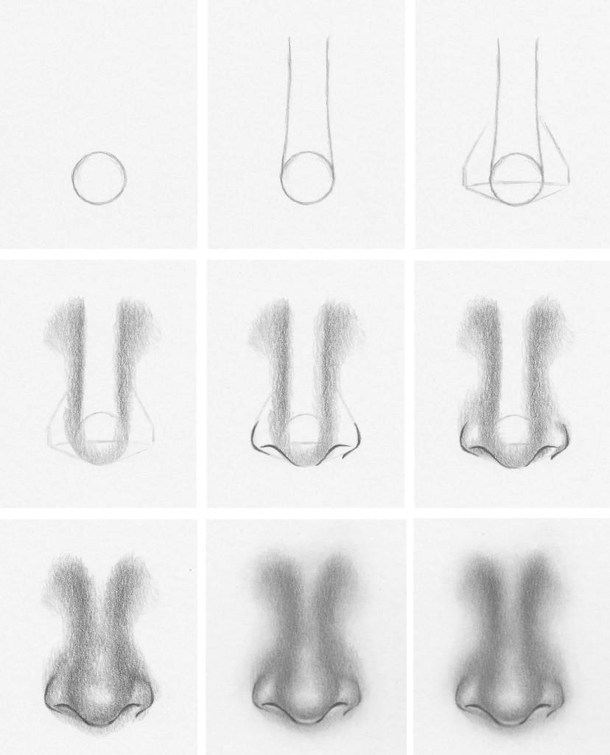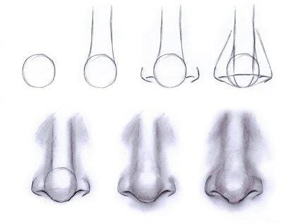

Return to Instructions

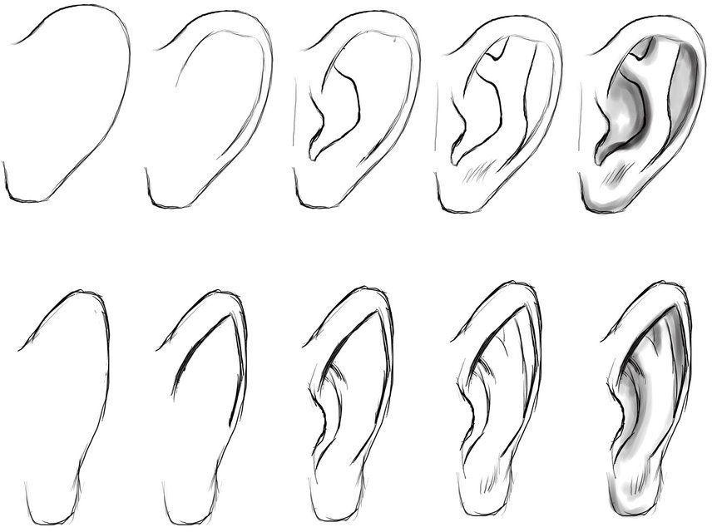
Return to Instructions

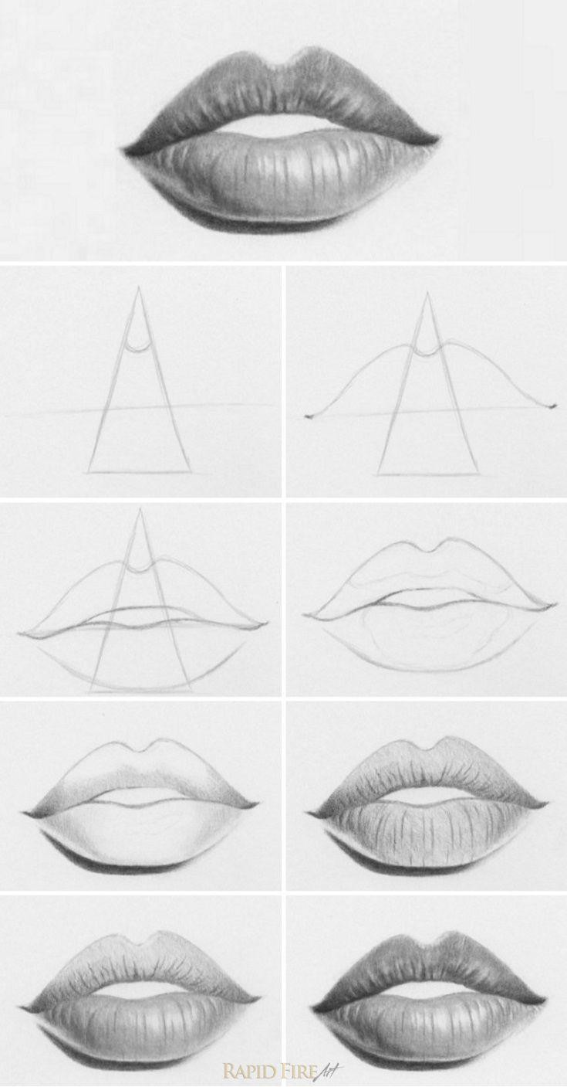
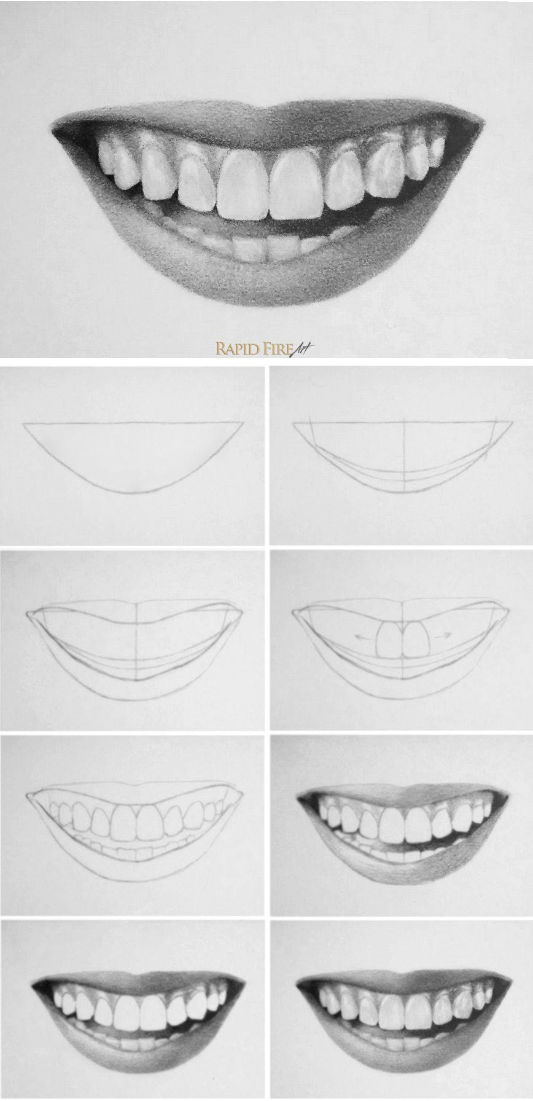

Return to Instructions

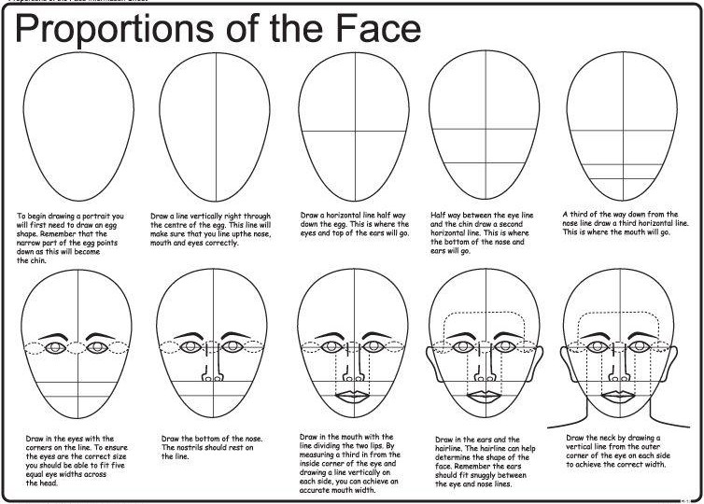
Return to Instructions

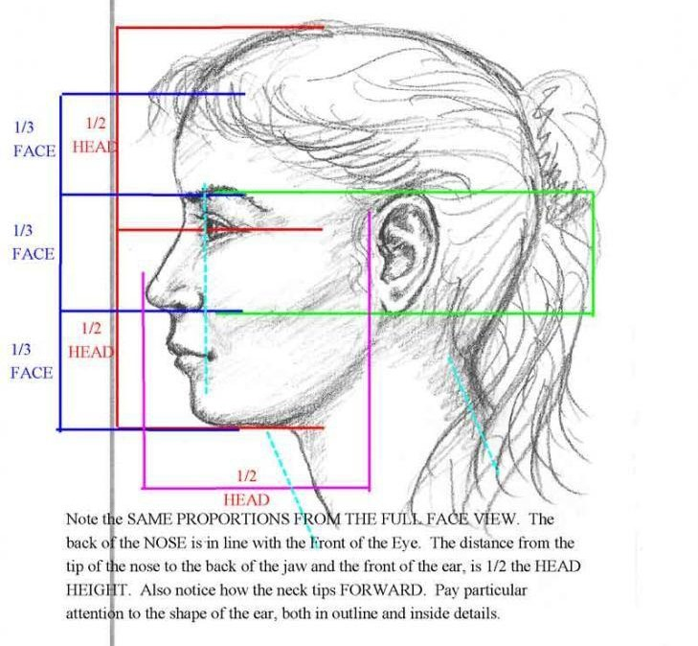

Return to Instructions

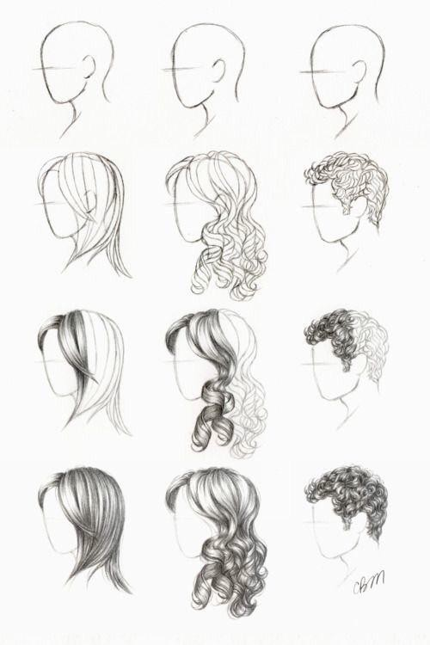

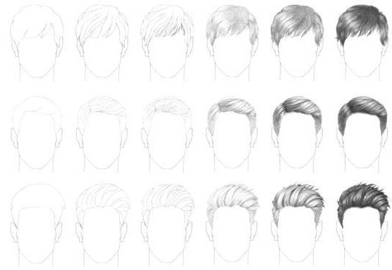

Return to Instructions

