Visual Art: Overall learning theme “The explorer within”
LO: Continue to improve your observational drawing skills using the materials you will have at home.
Develop your imagination and ability to juxtapose images together to create new artworks. Develop personalised and new ways of thinking and viewing the world.
Experiment with different media and new forms of art work from home. Be open to potential links to photography and poetry.
Task and media | T | Possible developments
Draw an eye using  Black or blue biro/pen to recap our tonal work in class.  https://www.youtube.com/watch?v=o_PcLQwdEbw  https://www.youtube.com/watch?v=-WR-FyUQc6I | How to draw realistic eye in Pen | https://www.youtube.com/watch?v=EEG2YbYn6IQ  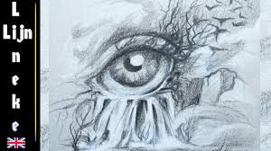
Self Portrait  Teach yourself how to draw a self portrait  Have a go with these tutorials  https://www.youtube.com/watch?v=-WR-FyUQc6I  How to Draw Faces  https://www.youtube.com/watch?v=iMEBSQJYaAY&t=243s  Fantasy figures  https://www.youtube.com/watch?v=5kK71t-I-2w  https://www.ashcancomicspub.com/ashcan-comics-pub-how-to-draw-a-self-portrait-real-fantasy.html | 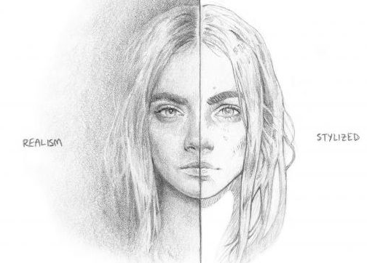 | 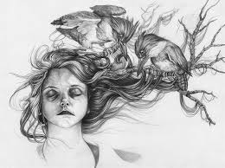
Tea stain ART  Create a series minimum of 10 exploratory tea wash images that can be developed into imaginative drawings. Tea bag art (Zentangle) to tea stain art. (ask folks first if you use tea)  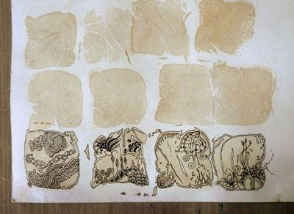 | 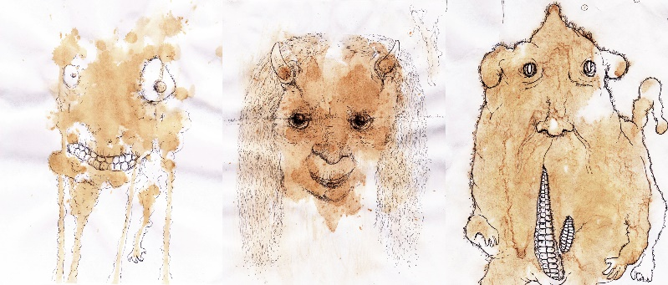  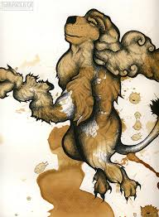  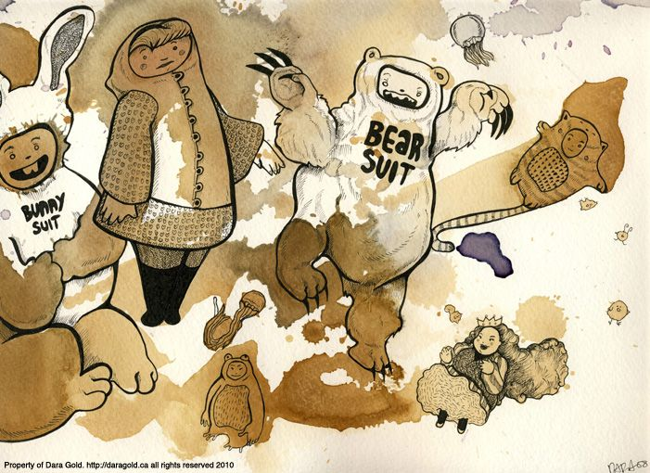  Explore different tea strengths and imaginative images | 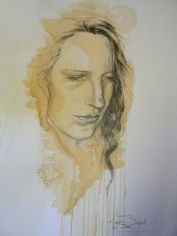  Explore weighted tone with  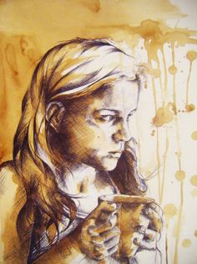  wash to create a portrait drawing that includes highlights (areas left white)
Task: Create a Surrealist image that juxtaposes at least 4 objects/subject matter together so that it appears seamless.  Artist models  Greg Craola Simpkins  Using the skills, you have learnt with how to draw observational objects using a range of tones to create a sense of form  Pencil  Pen/Biro  Tea/Coffee  Use white paint and water colour pencils if you have them for highlights  Artist models  Redmar Hoekstra  Greg Carola Simpkins  Simon Prades | 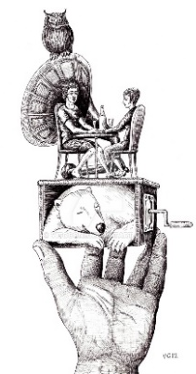 | Greg Craola Simpkins artist model  Watch: Greg "Craola" Simkins - Good Knight  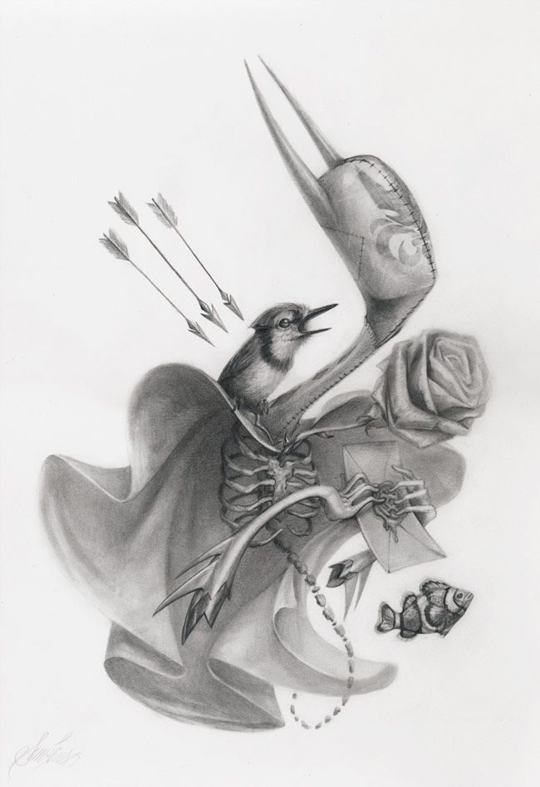  https://www.youtube.com/watch?v=58lswdTQOc0
Steampunk art  Task1: Combine mechanical house hold objects/animals into new Steampunk artefacts or figures  https://www.designyourway.net/blog/inspiration/steampunk-art/  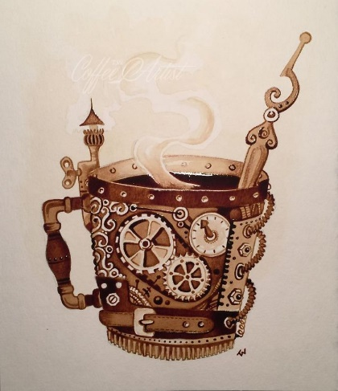  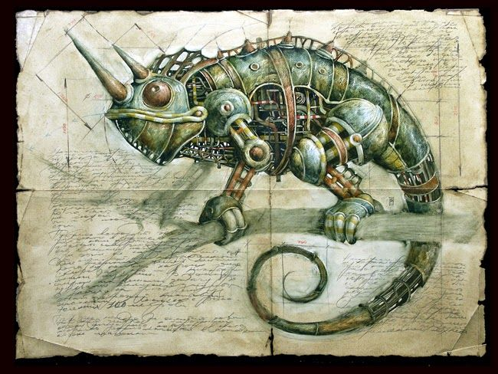 | 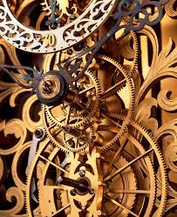  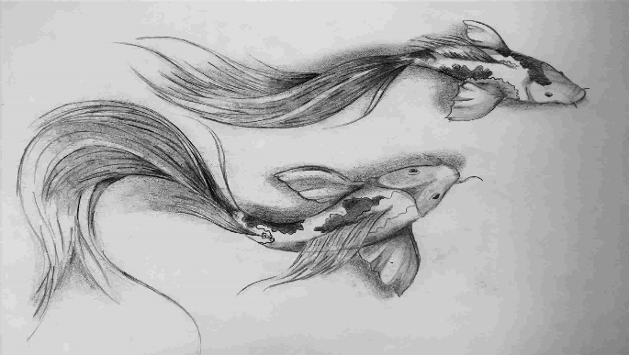  Process: Start with organic object (fish) and find inorganic mechanic subject matter (cogs) then combine … | Steampunk fantasy art (medieval theme?)  Design own figure using your portrait and figure skills.  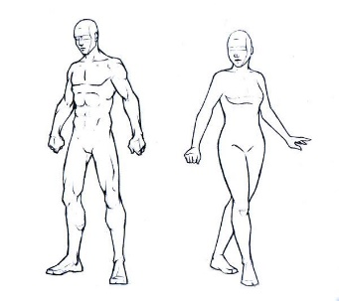  You can use figure template online to start you off or aphoto of yourself and draw/trace basic outline shape ¾ profile best)  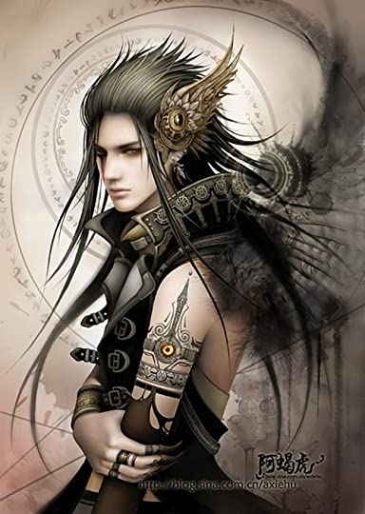
Black out Poetry art  Task: Create a black out poem from an old book or newspaper Black out Steam Punk Poem  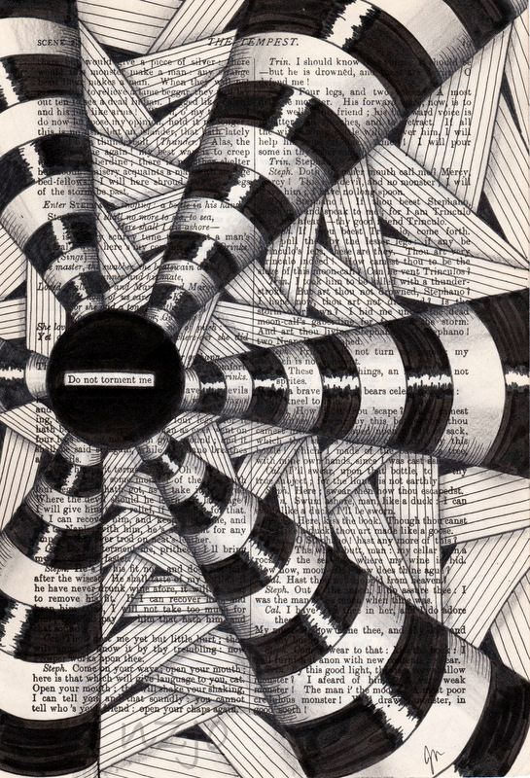 | Read: https://medium.com/offbeat-poetry/the-history-of-blackout-poetry-ca8985f04c35  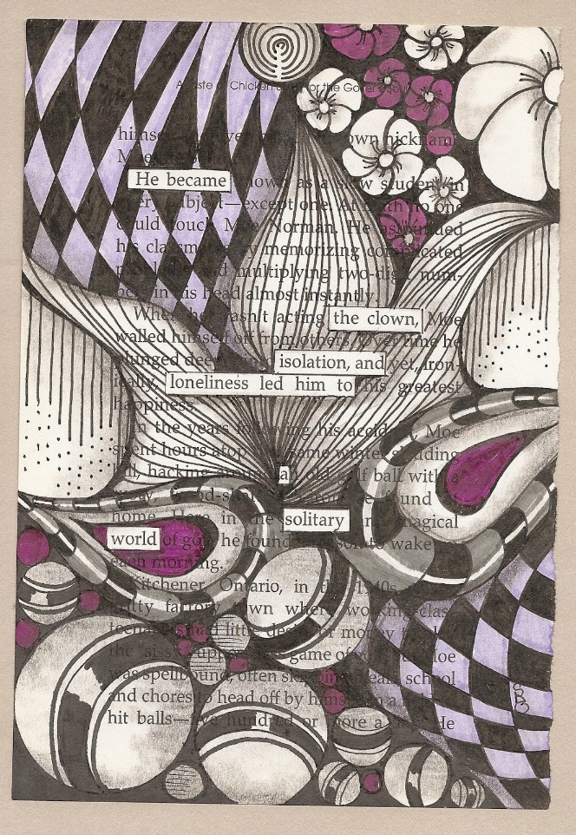 | 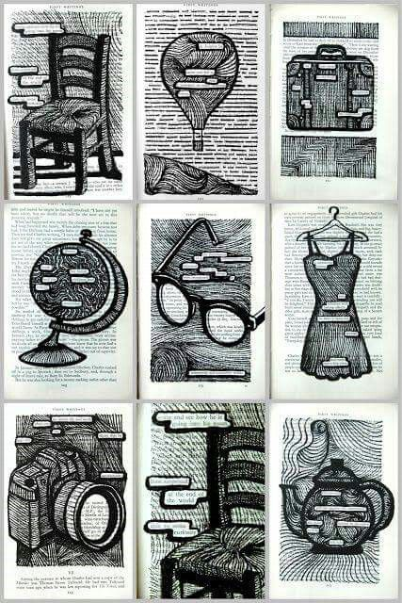
Task 1:Photography tasks: see PDF  Tasks: Close up to light  https://www.instagram.com/erinoutdoors/?utm_source=ig_embed  Task 2: Epic nature shots-inside, optical illusions  https://www.washingtonpost.com/travel/2020/04/08/travel-photographers-are-taking-epic-nature-photos-using-indoor-optical-illusions/  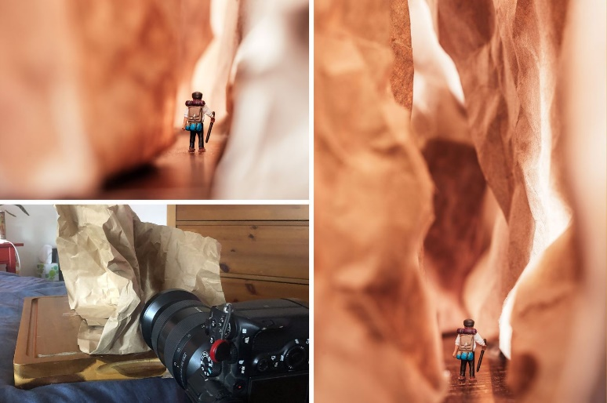 | 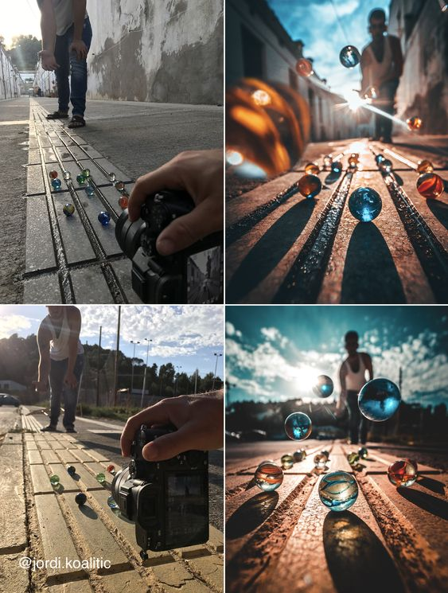  Task 3: Creative photography, scale, view point, found objects, light. | 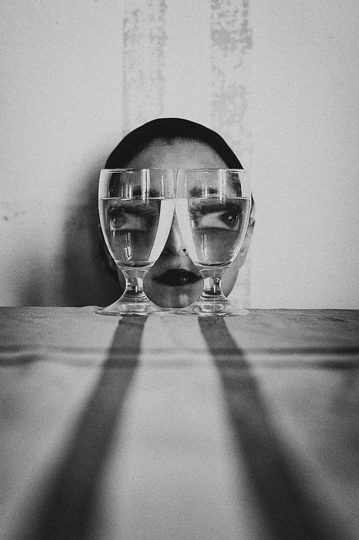  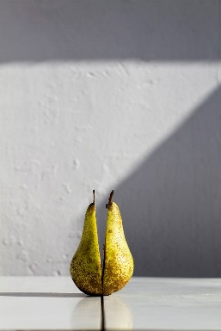  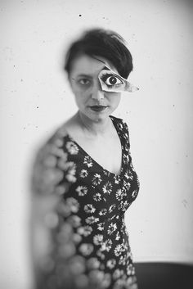  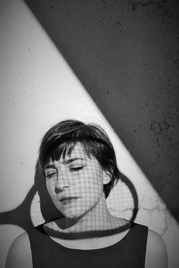  Task 4: Antonio Gutierrez Pereira photographer -try these reflective fun and imaginative shots at home.

