Mixed media drawing.  Using scrap paper, cutting out paper and drawing |  | 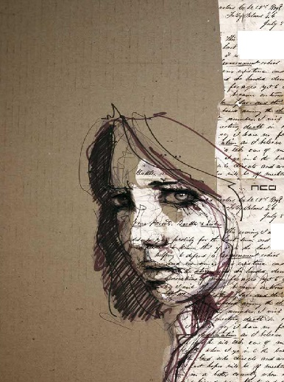  - 1 ---= J - ..  ½.:- : b ,.; ,.,,.' .,-  ' d 4 .,-/ ,.'t-  .J o  ,d,.'i.  :V.-'t..
you must incorporate a page with text from a newspaper or book with a cut out image. |  | 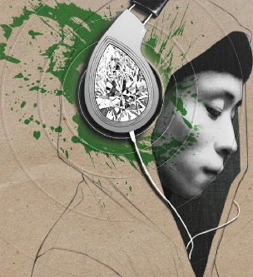
It can have collaged parts but must have drawing too. |  | 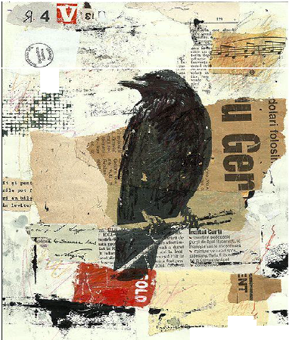  I  r /  - ---.  !  V  : ■_ J _1. .,.:.. I p ;,,  - .,.,.,,.....,,..  .N'....  (' 11A::C. -  .· ,  /Nd?t(I
Collage means paper and images cut out and stuck on another paper. You can layer images on top of each other. It can have collaged parts but must have drawing too. |  | 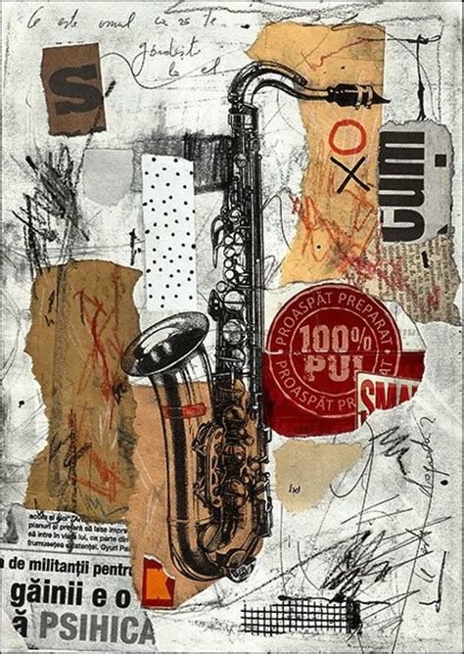
You can use white paint, ink, coffee or tea to stain the background and pencil. If you don’t have these things, some things around the house will work Try different things. Food colouring, things around the house. |  | 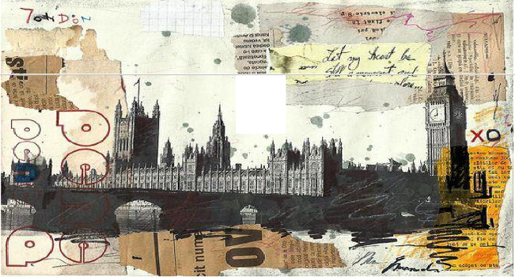  ..,.....  '!>  ...  1('°',1--e.  g  ...
- In your visual diary or on paper plan your drawing. What image will you use? what paper will you use? Will you use pen or pencil or both?  - When you have made your plan, stick the background paper down first.  - Draw or paint on top of the paper.  - Share what you have made with us @art.jchs instagram  - Have fun. | 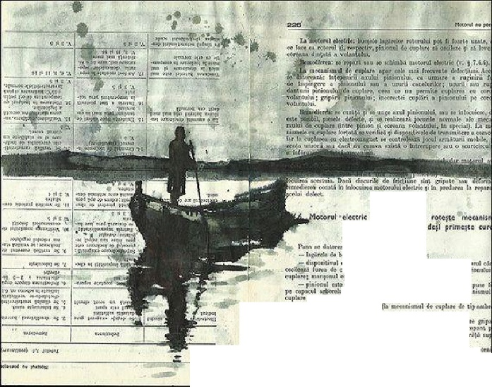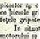  ' .r.-,_ p<linir u  - .,; ..,.,..ri...  ni;ole  oft  """'AMA  ,J..,,•,.;,,.,  - -  4.. <=U'tk t ,  - wxolllllu  l tl, l'>l  w- •  ...,..,,,...,1l""·  i  lrio iii> '""°"  •I 1,1 oi <l  l -.1 II- 4'ol<NIBL  TI  , '° lolt<""ltt:t' "'NON\ rli:,;,rn , I •Joi r" to  "'1 M m'I li,,; l'lu_t;, ,,. t•llrol t  -t - _ 1u •- .I ,lj,ili.._; ..  l,t>o t,, oivmr.il n. . . . . .  )> In il  · Ii:. I •11•1"'1, . ·
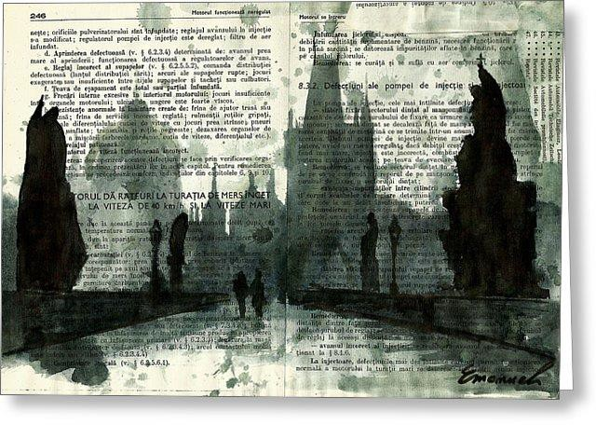 | 