James Cook High School 2020
VISUAL ART department
Mrs Katrina Bungard

VISUAL ARTS
PHOTOGRAPHY

LEVEL Three
91442 Version 2
VISUAL ARTS PHOTOGRAPHY 3.1
INTERNAL ASSESSMENT
CREDITS: 4

Analyse methods and ideas from established PHOTOGRAPHY practice

Achievement | Achievement with Merit | Achievement with Excellence
Analyse methods and ideas from established photography practice. | Analyse, in depth, methods and ideas from established photography practice. | Critically analyse methods and ideas from established photography practice.

“GO YOUR OWN WAY”
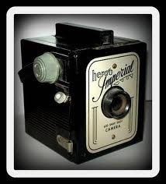

Visual Arts 3.1: Analyse methods and ideas from
established photography practice
“GO YOUR OWN WAY!”

Conditions:
DUE DATE:
22nd May 2020
Researching photographic styles, a range of photographers and identifying photographic conventions should take approximately 30 hours of work time.
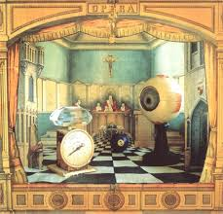
Task One: (10 Hours)
Research two styles of photography from the following list: Portraiture, staged photography,
still life, photomontage, documentary, landscape. (2 x A3 pages)

Task Two: (12 Hours)
Choose 3 different Photographers and Analyse.
(3 x A3 pages)

Task Three: (8 Hours)
Critically analyse relationships between Photographers and their key conventions.
(1 x A3 pages)

(Times are an indication only)

This activity involves the production of workbook-based material, which will serve students as inspiration for their photography work this year. Students will need to keep all of their notes in their workbook, as these will also contribute to their overall grade.

SUBMISSION CHECKLIST:

- Task One: At least 2 x A3 pages.
- Task Two: At least 3 x A3 pages.
- Task Three: At least 1 x A3 page

INTRODUCTION
This task takes place entirely in your workbook. (use the electronic templates provided)
There are three tasks in this assessment.
You must complete all tasks.

This Achievement Standard involves the production of a body of work that includes:
- Broad notes around two selected styles of photography. (Task 1)
- Annotated copies of works by a minimum of three Photographers. (Task 2)
- A summary of the key findings from your analysis that contains a page of collated findings summarised in paragraphs. (Task 3)

On completion of this assessment activity you will hand in your workbook containing all three tasks. For Achievement Standard 3.1 you will be assessed on your ability to demonstrate an in-depth and critical knowledge of the conventions associated with your selected style/movement.

TASK ONE: RESEARCH TWO PHOTOGRAPHIC STYLES.
(10 hours, 2 x A3 template pages)

Read broadly around your chosen styles and make relevant notes to demonstrate informed analysis of your styles. You need to use a wide range of sources and remember to acknowledge all of your sources. Research two styles of photography from the following list: Portraiture, staged photography, still life, photomontage, documentary, landscape. (2 x A3 pages – use template #1 provided)
SOME THINGS TO INCLUDE IN TASK ONE – USE TEMPLATE #1

- What do you like about the style?
- What does it remind you of / how does it make you feel?
- What are some strong characteristics in the style?
- Copy and paste some cool examples.

POSSIBLE STYLES TO
RESEARCH
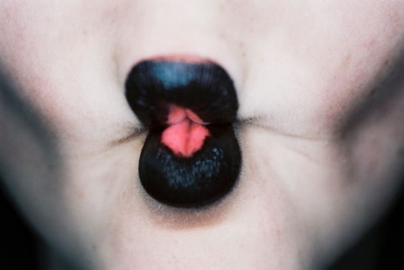

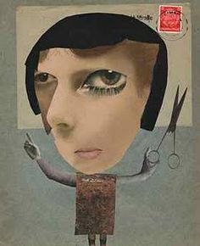

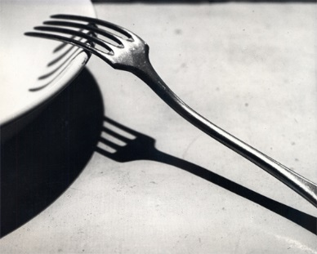
Staged Photography

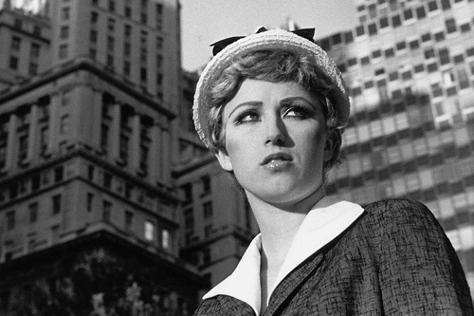

Still Life

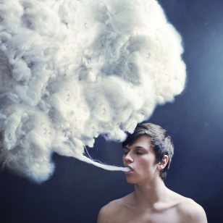

Photomontage
Portraiture
Surrealism

TASK TWO:PHOTOGRAPHERS ANALYSIS PAGES
(12 Hours, 3 x A3 template pages.)

Based on your style of research, select a minimum of three photographers to research. Select at least one photographer who works in a traditional way and at least one who works in a contemporary context.

Use template #2 – artist model analysis.

There is a list of appropriate artist models arranged by style / theme at the end of this document. Use this list to select your artist models for research.

Identify a typical work from each photographer for detailed analysis. Copy and Paste an image of each of these works into your worksheet templates provided.
Your notes need to cover the methods employed (the how) and the ideas behind the work (the why). Ideas should include some reference to the wider social, political, geographical, and historical influences of the photographers.

Make your notes as full as possible, one A3 page per photography artist model. Define those characteristics that are unique to each photographer, and the conventions which are common amongst the artists working in the chosen styles.

OTHER THINGS TO WRITE ABOUT
-The photographer’s method and ideas
-Any biographical information that has impacted on aspects of their photography
-The title, size, media, and function of each photograph example you have selected
-The technical processes they have used
-Any influences from other photographers or artists
-The themes or concepts that run through the photographer’s work
-How and why the artists have made their photographs
-How and why the artists and their work are valued by the wider artistic and photographic community
- How each artists work relates to a social, political, geographical, or historical context

*Reference specific visual examples of other photographers to support your discussion

TASK THREE: IDENTIFY CONVENTIONS
1 X A3 template Page – 8 Hours of work

Use template #3

From your analysis, collate your findings in a ‘connections page’. Use template #3 provided. Write paragraphs to summarise your findings in the main part of the template. Then in the compare and contrast section of the template, identify those characteristics or conventions that are common to two or more of the works between the artist models studied.

CONVENTIONS MAY INCLUDE (BUT ARE NOT LIMITED TO):

- Mixed media or interdisciplinary approaches
- Use of space
- Using a grid
- Use of colour
- Compositional principals
- Selection and arrangement of subject matter
- Use of iconography and symbolism
- Treatment of form – distortion and/or abstraction
- Scale and/or format
- Relationship with site, environment, or viewer
- Narrative aspects or message

Test your findings by looking at a broad range of work by other photographers who work within your chosen style. This is to see if the characteristics you have identified are common to most photographers who work within the style, and so can be rightly considered conventions.
STUDENTS CHECKLIST: - Use the provided A3 templates to complete your work. If you find you need extra room to type on you can expand your ideas by using an extra word document if you choose, and handing this in with your worksheets. Please label these and mark on the first worksheets if extra pages are used.

Task 1

2 x A3 worksheet template 1: Pages on 2 chosen photographic styles.

Task 2

Analyse a minimum of 3 different photographs from 3 different artist models (at least 1 from each photographic artist model).

3 x A3 Artist analysis templates: Photographers 1-3

Task 3

1 x A3: Identify conventions summary of findings worksheet.

The completed assignment consists of all 6 A3 template pages handed in and named.

EVIDENCE | Evidence/Judgements for Achievement | Evidence/Judgements for Achievement with Merit | Evidence/Judgements for Achievement with Excellence
TASK ONE  Research on 2 selected styles.  2x A3 Pages.  TASK TWO  Photographers analysis pages. At least 3x A3 research pages.  TASK THREE  Identify connections  1 x A3 page | The student demonstrates analysis of methods and ideas from established photography practice, within their chosen theme/movement/style.  The student’s notes identify relevant information and explain the methods and ideas of four photographers.  The student demonstrates understanding of why the photograph work was made and is effective.  The student identifies and describes the features of the photographer’s works and distinguishes any similarities and differences between them. | The student demonstrates in-depth analysis of methods and ideas from established photography practice, within their chosen theme/movement/style.  The student uses a range of sources for their research.  They identify key information about their four photographers, offering in-depth explanations of their methods and ideas.  The student demonstrates understanding of how and why the photograph was made and is effective, and references specific visual examples of other photographers to support their discussion. | The student demonstrates critical analysis of methods and ideas from established photography practice.  The student uses a wide range of sources for their research.  They identify key information about their selected four photographers, critically analysing their methods and ideas.  The student offers personal insight into how and why the photograph was made and is done so effectively.  They examine the relationships between the approaches of the photographer and significant wider social, political, geographic, or historical contexts they relate to, and references specific visual examples of other photographers to support their discussion.

Explanatory notes

Analyse means to pick out and make a list of specific features that are similar or different between the approaches investigated.

In-depth analysis means that you must explain why these features are similar or different. Possible reasons for this include environmental, political, social, personal, or technological changes.

Critical analysis places the work in a much wider context. You could broaden and deepen the discussion by examining other works by the photographers or introducing other new photographers and photography works that have influenced to the development between selected approaches.

A personal summary of the influences, significance and intentions of the selected approaches helps to show a greater depth of understanding.

Please Note - For this assignment I’m looking out for quality of discussion in your writing rather than pretty pages. Naturally you may have photos, practice sketches and different handwriting notes etc. which you can include.

POSSIBLE ARTISTS TO RESEARCH
WITHIN PHOTOMONTAGE AND STAGED PHOTOGRAPHY
Useful resources include (but are not limited to) books, websites, magazine and newspaper articles, and exhibition visits about the following art movements and artists.
Photography models by Thematic Approaches
Portait | Figures | Architectural | Still Life
Louis Daguerre | Dorothea Lange | Louis Daguerre | Louis Daguerre
Alexander Rodchenko | Man Ray | Charles Sheeler | André Kertész
Henri Cartier-Bresson | Edward J. Steichen | Eugène Atget | Edward Weston
Alfred Eisenstaedt | Cecil Beaton | Walker Evans | Imogen Cunningham
Cecil Beaton | Edward Weston | Margaret Bourke-White | Josef Sudek
Walker Evans | Philippe Halsman | Bernd and Hilla Becher | Karl Blossfeldt
Dorothea Lange | Ralph Gibson | Lucia Moholy | Man Ray
Paul Strand | Robert Mapplethorpe | Alexander Rodchenko | Paul Outerbridge
Diane Arbus | Rineke Dijkstra | Joel Meyerowitz | Paul Strand
Philippe Halsman | David Hockney | Edward J. Steichen | Jerry Takigawa
Bruce Davidson | Pavel Banker | André Kertész | Olivia Parker
Cindy Sherman | Peter Greenaway | Keith Carter | Eileen Cowin
Duane Michaels | Vincent Serbin | Candida Hofer | Jan Groover
Luis Gonzalez Palma | Maggie Taylor | Robert Adams | Robert Mapplethorpe
Pavel Banka | Martina Lopez (Aus) | Lee Friedlander | James Welling
Annie Liebowitz) | Joel-Peter Witkin | William Eggleston | Audrey Flack
Barbara Kruger | Christopher Bucklow | James Casebere | Adam Fuss
Robert Heinecken | Jan Saudek | Thomas Demand | Abelardo Morell
Jim Goldberg | Keith Carter | Idris Khan | Sarah Charlesworth
Gilbert & George | Ruth Thorne-Thompson | Maureen Broadbeck | Eberhard Grames
Robert Mapplethorpe | David Hilliard | Robin Morrison (NZ) | Carl Chiarenza
Sally Mann | Anthony Giocolea | Laurence Aberhart (NZ) | Joachim Froese
Vik Muniz | Angie Buckley | Andrew Ross (NZ) | Jan Groover
Ralph Gibson | Bill Armstrong |  | Carol Golemboski
Loretta Lux | Ava Seymour (NZ) |  | Laura Letinsky
Julian Ward (NZ) | Margaret Dawson (NZ) |  | Alan Knowles (NZ)
Peter Black (NZ) | Christine Webster (NZ) |  | Peter Peryer (NZ)
Margaret Dawson (NZ) | Siren Deluxe (NZ) |  | Fiona Pardington (NZ)
Marti Friedlander (NZ) | Lisa Reihana (NZ) |  | Peter Madden (NZ)
Peter Peyer (NZ) | Burton Brothers (NZ)
Glen Busch (NZ)
Body Parts | Flowers | Documentary | Interiors
Bill Brandt | Imogen Cunningham | Brassaï | André Kertész
Edward Weston | André Kertész | Diane Arbus | Walker Evans
Man Ray | Josef Sudek | Dorothea Lange | Ralph Gibson
Robert Mapplethorpe | Karl Blossfeldt | Henri Cartier-Bresson | Edward Weston
Ralph Gibson | Amy Melious | Margaret Bourke-White | Eugène Atget
Eileen Cowin | Robert Mapplethorpe | Walker Evans | Lucia Moholy
Imogen Cunningham | Olivia Parker | Alfred Eisenstaedt | Robert Adams
Anne Noble (NZ) | James Welling | Bruce Davidson | Louise Lawler
Christine Webster (NZ) | Anne Geddes | Lee Friedlander | Joel Meyerowitz
Peter Peryer (NZ) | Adam Fuss | Sebastiao Salgado | Candida Hofer
Siren Deluxe (NZ) | Starn Twins | Sally Mann | Rhona Bitner
 | Peter Peryer (NZ) | Cindy Sherman | Ray Metzker
 | Anne Noble (NZ) | William Eggleston | Laurie Simmons
 |  | Marti Friedlander (NZ) | Uta Barth
 |  | Ans Westra (NZ) | William Eggleston
 |  | Peter Black (NZ) | Wynn Bullock
 |  | Julian Ward (NZ) | Andrew Ross (NZ)
 |  | Robin Morrison (NZ) | Peter Black (NZ)
 |  | Anne Shelton (NZ) | Laurence Aberhart (NZ)
Landscape | Abstract
Ansel Adams | Alexander Rodchenko
Edward Weston) | Josef Sudek
Dorothea Lange | Franco Donaggio
JoAnn Verburg | Bill Brandt
Lee Friedlander | Karl Blossfeldt
Paul Caponigro | László Moholy-Nagy
Gustave Le Gray | Man Ray
Richard Misrach | Paul Strand
Terry Evans | Minor White
William Eggleston | James Welling
Bruce Foster (NZ) | Adam Fuss
Natalie Robertson (NZ) | Christopher Bucklow
Laurence Aberhart (NZ) | Olivia Parker
Wayne Wilson Wong (NZ) | Sarah Charlesworth
Robin Morrison (NZ) | Uta Barth
Ronnie Van Hout (NZ) | Fiona Pardington (NZ)
Mark Adams (NZ) | Alan Knowles (NZ)
Julian Ward (NZ) | Peter Peryer (NZ)

Photography Compositional / Technical Approaches
Photomontage  Surrealism | Multimedia | Grid Format
Hannah Hoch | Hannah Hoch | Edward Muybridge
John Heartfield | Lazlo Moholy -Nagy | Bernd and Hilla Becher
Max Ernst | Max Ernst | David Hockney
László Moholy-Nagy | John Heartfield | Duane Michaels
Ruth Thorne-Thompson | Richard Hamilton | Uta Barth
Bob Bennet | Christian Boltanski | Luis Gonzalez Palma
Jerry Uelsmann | Joseph Cornell | Tracey Moffat (Aus)
Jerry Takigawa | Nick Bantock | Starn Twins
Thomas Barbey | Barbara Kruger | Lorna Simpson
Annie Liebowitz | Annette Messager | Nate Larson
Luis Gonzalez Palma | Sarah Charlesworth | Deborah Smith
Joel Peter Witkin | Luis Palma | Gilbert and George
Scott Mutter | Sigmar Polke | David Hockney
Maggie Taylor | Jim Goldberg | Tatana Kellner
Gilbert and George | Martina Lopez (Aus) | Jan Groover
Peter Greenaway | John Rooff | Sarah Charlesworth
Jan Saudek | Joseph Cornell | Natalie Robertson
Robert ParkeHarrison | Megan Jenkinsen (NZ) | Francesca Woodman
Chema Madoz | Ava Seymour (NZ) | Gerhard Richter
Jon Goto | Judy Darragh (NZ) | Joachim Froese
Maureen Broadbeck |  | Lloyd Goodman (NZ)
Lisa Reihana (NZ)
Julie Firth (NZ)
Megan Jenkinsen (NZ)

Photomontage: | Staged Photography:
Hannah Hoch (Germany)  John Heartfield (Germany)  Laszlo Moholy Nagy (Hungary)  Max Ernst (Germany)  Bob Bennet (USA)  Anne Liebowitz (USA)  Maggie Taylor (USA)  Peter Greenaway (UK)  Jerry Uelsmann (USA)  Gilbert and George (UK  Jan Saudek (Czech)  Luis Gonzalez Palma (Guatemala)  Martina Lopez (Aus)  Barbara Kruger (USA)  Annette Messager (France)  David Hockney (UK)  Mary Macpherson (NZ)  Ava Seymour (NZ)  Boyd Webb (NZ)  Megan Jenkinson (NZ)  Lisa Reihana (NZ) | Loretta Lux (Germany)  Sandy Skoglund (USA)  Sam Taylor-Wood (UK)  Anthony Giocolea (USA)  David Hilliard (USA)  Duane Michals (USA)  Cindy Sherman (USA)  Wang Qingsong (China)  Gregory Crewdson (USA)  AES+F (Russia)  Mariko Mori (Japan)  Anne Noble (NZ)  Yvonne Todd (NZ)  Fiona Pardington (NZ)  Margaret Dawson (NZ)  Rhondda Bosworth (NZ)  Ben Cauchi (NZ)  Tracey Moffat (Aus)  Christine Webster (NZ)  Marie Shannon (NZ)  Deborah Smith (NZ)  Ben Cauchi (NZ)

