James Cook High School 2020
VISUAL ART department
Mrs Bungard

VISUAL ARTS
PAINTING

LEVEL Three
91441 Version 2
VISUAL ARTS PAINTING 3.1
INTERNAL ASSESSMENT
CREDITS: 4

Analyse methods and ideas from established painting practice
Achievement | Achievement with Merit | Achievement with Excellence
Analyse methods and ideas from established painting practice. | Analyse, in depth, methods and ideas from established painting practice. | Critically analyse methods and ideas from established painting practice.

DISCOVER A WAY
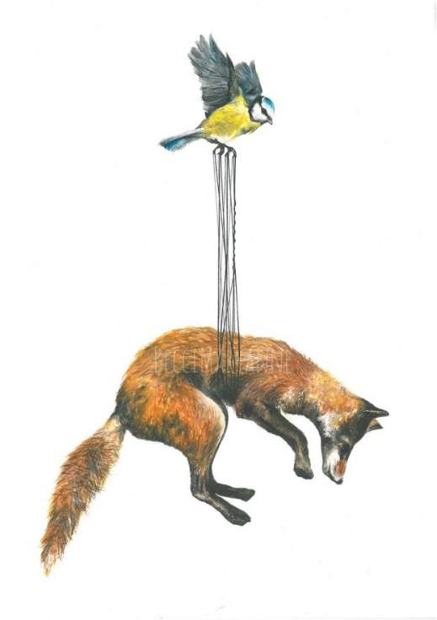

Visual Arts 3.1: Analyse methods and ideas from
established painting practice
“GO YOUR OWN WAY!”

Conditions:
DUE DATE:
22 May 2020
Research painting styles, a range of artists and identifying painting conventions should take approximately 30 hours of work time.

Task One: (10 Hours)
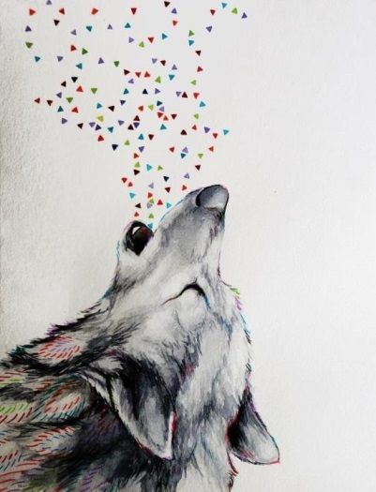
Research any two styles of painting from the following list: Portraiture, Surrealism, Graffiti Art, Modernism, Pop Art, Impressionism, Post Impressionism, Expressionism, Post Modernism, Abstract Expressionism.
Still Life, Landscape. (2 x A3 pages)

Task Two: (12 Hours)
Choose 3 different painting artists and Analyse.
(3 x A3 pages)

Task Three: (8 Hours)
Critically analyse relationships between painters and their key conventions.
(1 x A3 page)

(Times are an indication only)

This activity involves the production of workbook-based material, (Use templates provided), which will serve students as inspiration for their painting work this year. Students will need to keep all of their notes in their workbook, as these will also contribute to their overall grade.

SUBMISSION CHECKLIST:

- Task One: At least 2 x A3 pages.
- Task Two: At least 3 x A3 pages.
- Task Three: At least 1 x A3 page

INTRODUCTION
This task takes place entirely in your workbook. (use the electronic templates provided)
There are three tasks in this assessment.
You must complete all tasks.

Task One: (10 Hours)

Resource
Requirements:

Art department books for this project are: Contemporary NZ International art books Design magazines/journals PINTEREST

Student access to Public, School and Art department libraries as well as the Internet would be desirable.

Introduction

This task takes place entirely in your workbook. (using the A3 templates provided)
There are three tasks in this assessment.
You must complete all tasks.
This research project will prepare you for 3.2 and 3.4 Achievement Standards.
It involves collating:

- Broad notes around selected styles of painting. (Task 1)
- Annotated copies of works by a minimum of three Painters. (Task 2)
- A summary of the key findings from your analysis that contains writing paragraphs and comparing artists work. (Task 3)

On completion of this assessment activity you will hand in your workbook containing all three tasks. (6 x A3 template pages).

For Achievement Standard 3.1 you will be assessed on your ability to demonstrate an in-depth and critical knowledge of the conventions associated with your selected painting styles.

TASK ONE: RESEARCH STYLE AND PAINTERS.

Duration: 10 Hours
Expectation: 2 x A3 Pages - Use template #1
Select 2 different styles of painting from the following list: Portraiture, Surrealism, Graffiti Art, Modernism, Pop Art, Impressionism, Post Impressionism, Expressionism, Post Modernism, Abstract Expressionism.
Still Life, Landscape.

Read broadly around your styles and make relevant notes to demonstrate informed analysis of your chosen styles. You need to use a wide range of sources and remember to acknowledge all of your sources.

THINGS TO INCLUDE IN TASK ONE

What do you like about the theme/style?
What does it remind you of?
What are some strong characteristics in the style?
Copy and paste some cool examples.

POSSIBLE STYLES/MOVEMENTS TO
RESEARCH

-Surrealism

-Multi-media/layering

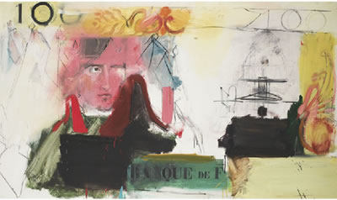

-Pop Art

-Text and graphics

Street Art / Graffiti

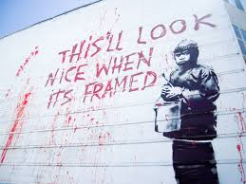

-Figurative / portraiture

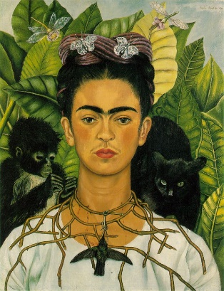

-Expressionism
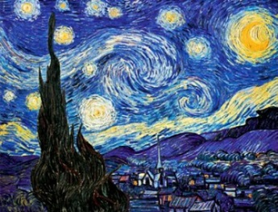

-Landscape
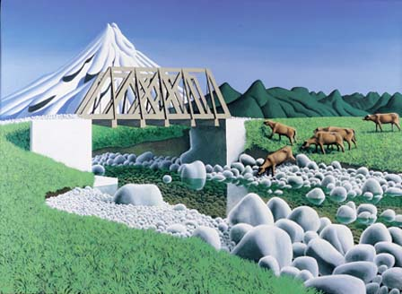

-Still life

-Still life

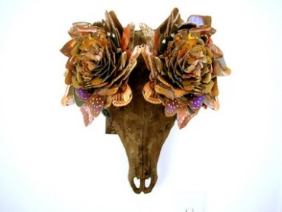

TASK TWO: ARTIST ANALYSIS PAGES

Duration: 12 Hours
EXPECTATIONS : 3 x A3 PAGES - Use template #2

Based on your theme of research, select a minimum of three painters to research.

Identify a typical work from each painter for detailed analysis. Copy and paste an image of each of these works (in colour) into the template provided. Then use the sections of the template to write notes about the style and content of the selected work. Your notes need to cover the methods employed (the how) and the ideas behind the work (the why). Ideas should include reference to the wider social, political, geographical, and historical influences of the painters.

Remember to write about the following topics under the template headings provided. Some of the topics you will cover for each painting include ideas about the following:

-Media/techniques
-composition
-Messages
-Colours

OTHER THINGS TO WRITE ABOUT

-The painter’s method and ideas
-Any biographical information that has impacted on aspects of their painting
-The title, size, media, and function of each painting example you have selected
-The technical processes they have used
-Any influences from other painters or artists
-The themes or concepts that run through the painter’s work
-How and why the artists have made their paintings
-How and why the artists and their work are valued by the wider artistic and painting community
- How each artists work relates to a social, political, geographical, or historical context.

TASK THREE: IDENTIFY CONVENTIONS
1 X A3 template Page – 8 Hours of work

Use template #3

From your analysis, collate your findings in a ‘connections page’. Use template #3 provided. Write paragraphs to summarise your findings in the main part of the template. Then in the compare and contrast section of the template, identify those characteristics or conventions that are common to two or more of the works between the artist models studied.

CONVENTIONS MAY INCLUDE (BUT ARE NOT LIMITED TO):

- Mixed media or interdisciplinary approaches
- Use of space
- Using a grid
- Use of colour
- Compositional principals
- Selection and arrangement of subject matter
- Use of iconography and symbolism
- Treatment of form – distortion and/or abstraction
- Scale and/or format
- Relationship with site, environment, or viewer
- Narrative aspects or message

Test your findings by looking at a broad range of work by other painters who work within your chosen style. This is to see if the characteristics you have identified are common to most painters who work within the style, and so can be rightly considered conventions.

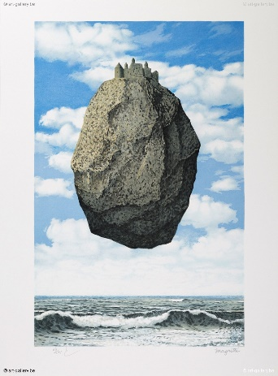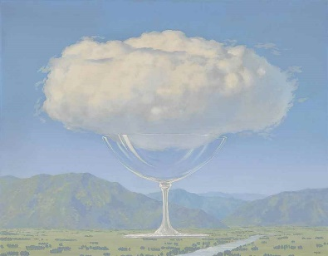

STUDENTS CHECKLIST: - Use the provided A3 templates to complete your work. If you find you need extra room to type on you can expand your ideas by using an extra word document if you choose, and handing this in with your worksheets. Please label these and mark on the first worksheets if extra pages are used.

Task 1

2 x A3 worksheet template 1: Pages on 2 chosen painting styles.

Task 2

Analyse a minimum of 3 different paintings from 3 different artist models (at least 1 from each painter artist model).

3 x A3 Artist analysis templates: Painters 1-3

Task 3

1 x A3: Identify conventions summary of findings worksheet.

A complete assignment consists of:
All 6 A3 template pages handed in and named

Referenced all work that is not your own!

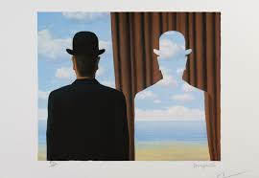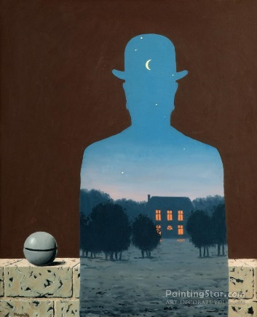

EVIDENCE | Evidence/Judgements for Achievement | Evidence/Judgements for Achievement with Merit | Evidence/Judgements for Achievement with Excellence
TASK ONE  Research 2 selected styles.  2x A3 Pages.  TASK TWO  Painters analysis pages. AT least 3xA3 research pages.  TASK THREE  Identify connections  Summarise findings  1xA3 Page | The student demonstrates analysis of methods and ideas from established painting practice, within their chosen theme/movement/style.  The student’s notes identify relevant information and explain the methods and ideas of four painters.  The student demonstrates understanding of why the painting work was made and is effective.  The student identifies and describes the features of the photographer’s works and distinguishes any similarities and differences between them. | The student demonstrates in-depth analysis of methods and ideas from established painting practice, within their chosen theme/movement/style.  The student uses a range of sources for their research.  They identify key information about their four painters, offering in-depth explanations of their methods and ideas.  The student demonstrates understanding of how and why the painting was made and is effective, and references specific visual examples of other painters to support their discussion. | The student demonstrates critical analysis of methods and ideas from established painting practice.  The student uses a wide range of sources for their research.  They identify key information about their selected four painters, critically analysing their methods and ideas.  The student offers personal insight into how and why the painting work was made and is done so effectively.  They examine the relationships between the approaches of the painters and significant wider social, political, geographic, or historical contexts they relate to, and references specific visual examples of other painters to support their discussion.

Explanatory notes

Analyse means to pick out and make a list of specific features that are similar or different between the approaches investigated.

In-depth analysis means that you must explain why these features are similar or different. Possible reasons for this include environmental, political, social, personal, or technological changes.

Critical analysis places the work in a much wider context. You could broaden and deepen the discussion by examining other works by the painters or introducing other new painters and painting works that have influenced to the development between selected approaches.

A personal summary of the influences, significance and intentions of the selected approaches helps to show a greater depth of understanding.

Please Note
-For this assignment I’m looking out for quality of discussion in your writing rather than pretty pages. Naturally you may have photos, practice sketches and different handwriting notes etc. which you can include.

Year 13 PAINTING
Achievement Standard 3.1 – AS91441
Analyse methods and ideas from established painting practice: ‘Discover a way”

STUDENT: _________________________________ DATE: ___________________

GRADE AWARDED: __________________________

