03TACE Project Two March 2020
Coffee table example
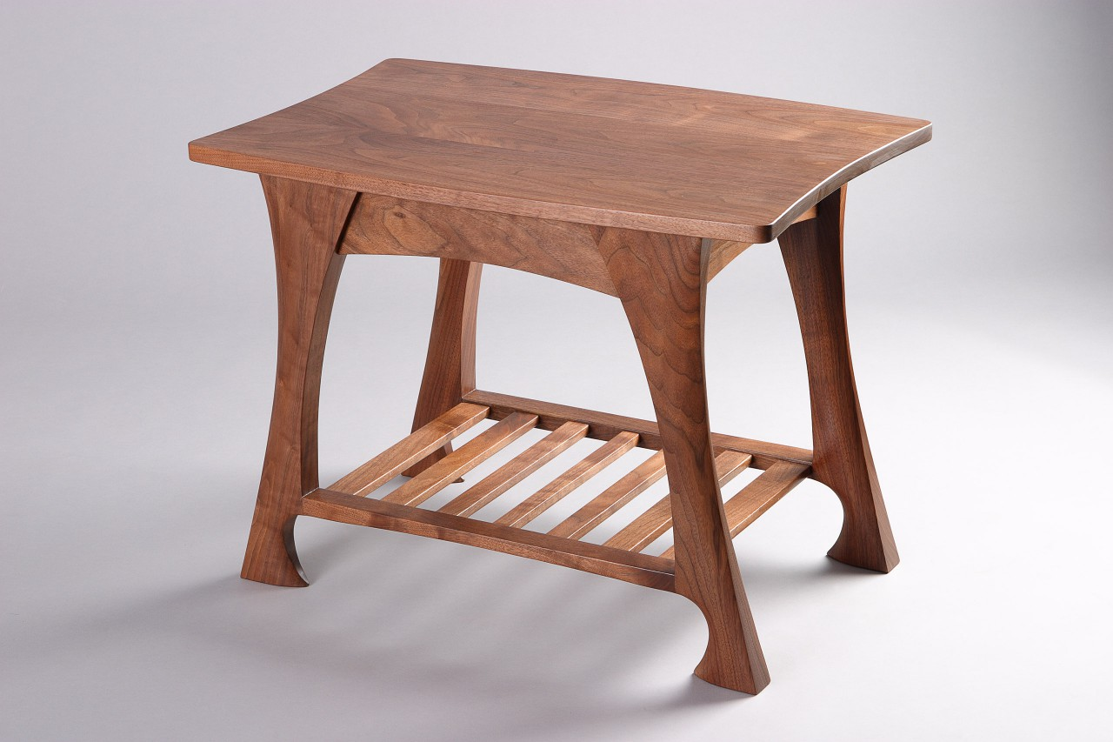

1. Plan and design your own coffee table.
No larger than 90x40 cm.
The project design needs to include curves in the top, base or the leg structures.

The plan(drawings)are to show at least three angles of your project,
For example: a. front view
b. side view
c. birds eye view or top view

2. In each view of the coffee table the measurements need to be shown.

3. Students need to make a list of materials needed for this project.

Wood type ……….
Calculate wastage of wood at 15 %
Fastenings needed bolts screws nails dowels etc…quantities…
Make a list of Tools, hand tools, machinery required to complete this project.
PPE check list Required…….

4. Finishing of product – Table

Students are to describe the type of finishing needed to complete their project.
E.g. varnish, oil, paint etc….
Calculate the surface area of your project and how much oil or paint is needed to cover this project.
Calculate the total cost of the project from start to the finished product using the Bunnings website for wood and material prices.

BCATS 29681 Measure and calculate

These things must be included in your project paperwork:
You will use these calculations; area, addition, multiplication, percentage,
And answers will be in lineal meters metres centimetres, millimetres and metres square or
Area=length x width, +, x, %, LM, cm, m, m²
Costing needs to be in dollars and cents or $, c

Checklist:
Photo of proposed project
Three drawings of project
Full Tool list needed to make project
PPE required for the project
Materials list / cutting list including wood type, fastenings etc
Costing for the project

Project completed in hardcopy or designed and put together on computer to be sent to tutors when school resumes –
Email: admin@kiwa.ac.nz
Subject: 03TACE your school and your Name

Hardcopy All work named.

Bring all this paperwork in when school resumes to be marked.

Stay safe and at home and we will see you all soon

